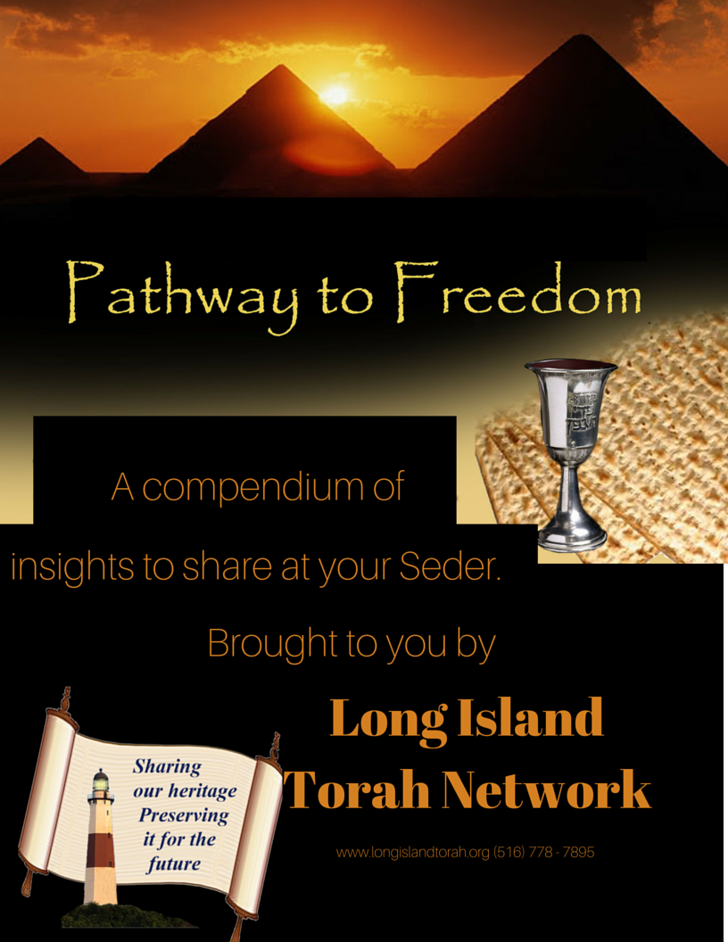

A compendium of insights
to share at your Seder.

Brought to you by
LONG ISLAND TORAH NETWORK
www.longislandtorah.org (516) 778 - 7895

WHAT IS FREEDOM?
- And you shall tell your son on that day, saying, “Because of this G-d acted on my behalf when I left Egypt.”
[Exodus 13:8; Haggadah, the Four Sons]
“Because I will fulfill His commandments, such as Pesach, Matzah and Maror.”
[Rashi – 10th Century]
- Read Rashi’s words carefully. Which is the cause, and which is the effect?

- Praise, O servants of G-d; praise the name of G-d!
[Opening words of Hallel]
[Why don’t we say Hallel on Purim?] Rava said, “[On Passover, we can say] ‘Praise, O servants of G-d’ – and not servants of Pharaoh; but [in the story of Purim] we remain servants of Achasverosh!”
[Talmud Megillah 14a]
- Freedom is the opposite of slavery. How is a servant of G-d the opposite of a servant of Man?

- A man or woman who expresses a vow of Nazir, to separate [temporarily from certain physical pleasures in honor of] G-d …
[Numbers 6:2]
This section is about quieting discord and destruction within oneself, which comes from one’s physical craving, which can lead to sin…Quieting this discord is first in order, prior to peace in the home and peace in the country [which are also discussed in this Torah portion, and can be developed once there is inner peace]….
[Rabbi Levi ben Gershom (Ralbag) – 14th Century]
- How can we balance the needs of body and soul, and attain inner peace?

- This is truly one of the strategies of the Evil Inclination, and an aspect of his cleverness – to burden people’s hearts constantly with his service, until they are left with no space to focus and contemplate on which path they are traveling; for he knows that were they to but place the slightest attention to their paths, they would, unquestionably, immediately begin to reconsider their actions... until they would abandon sin entirely.
This is akin to the idea of the wicked Pharaoh, who said, “Let the work lie heavily on the men and let them be involved in it, and not turn to words of falsehood” – he intended to leave them no space at all, that they place no focus or take no counsel against him; he tried to distract their heart from any contemplation, by the force of unceasing labor.
[Rabbi Moshe Chaim Luzzato, Path of the Just, Chapter 2 – 18th Century]
- What does freedom mean in today’s terms? How is it attained?

The Mitzvos of Passover seem designed to recall a historical event. But the truth is the opposite: G-d “looked into the Torah and created the world.” The Mitzvos came first; the Exodus followed.

Mitzvos are not a means to an end, but the end itself; they are the way we achieve our spiritual potential. This is the Jewish concept of freedom. “The only free person is the one involved in Torah.” Without responsibilities, we remain slaves to desire and negative emotions. By subjugating ourselves to G-d’s instruction, we become free to attain greatness.

The conflict between body and soul leaves us unhappy and discontent. When we learn to give primacy to our souls – not negating the body, but channeling it in the service of spirituality – we attain happiness and inner peace.

Pharaoh understood that to subjugate the Jews, he had to deprive them of the opportunity for contemplation. This strategy is used against us by the Evil Inclination: it keeps us too preoccupied and distracted to focus on the purpose of life. It, too, is a “master,” subjugating us in the burdens of daily life to keep us from fulfilling our potential. Through Torah, we attain freedom: by making time to learn and absorb Torah’s message, we create an island of tranquility in which we can pursue life’s purpose.

FAITH AND MIRACLES
- Say to the Children of Israel, “I am G-d! And I shall extricate you from the burdens of Egypt, and I shall save you from their service, and I shall redeem you with an outstretched arm, and great judgments. And I shall take you to Me as a people and I shall be your G-d…And I shall bring you to the Land….and I shall give it to you as an inheritance; I am G-d.”
Moses spoke thus to the Children of Israel; but they did not listen to Moses, out of shortness of spirit and hard labor.
[Exodus 6:6-9]
“I shall bring you to the Land” – when you contemplate all this, you shall be worthy that I bring you to the Land and give it to you.
“But they did not listen to Moses” – to contemplate all this in a manner that they would have trusted in the salvation of the G-d… Therefore, “I shall give it to you” was never fulfilled for them, but it was given to their children.
“And from hard labor” – because if not for the hard labor, they would have paid heed to the words of Moses…
[Commentary of Rabbi Ovadia Sforno – 15th-16th Century]
- The Torah writes explicitly that the Jews did believe in Moses, from the very beginning. What did they not do? What could they have done differently?
- How could this incident be a factor to prevent their entry into the Land? Wouldn’t the lessons of the Exodus elevate their level of faith, and compensate for their initial shortcoming?

When Moses came to free them, the Jews believed him – but failed to absorb his message emotionally. They did not fully feel a sense of hope and trust in the upcoming redemption. How could they? The brutal conditions had not changed, and actually intensified after Moses first came to Pharaoh. Yet the Torah testifies that they could have done better; within their dreadful suffering they could have found the strength to focus, contemplate and absorb Moses’ message, developing faith in G-d and anticipation of His salvation. Such is the greatness of the human spirit.

Because of this shortcoming, they never entered the Land. Everything they later experienced – the Ten Plagues, the Splitting of the Sea, the Revelation at Sinai, Manna from Heaven and water from the rock – could not make up for what they had not done themselves. There is no question that they grew immeasurably from each experience; but they could have grown even greater, had they invested more effort from the outset. In the final analysis, only through our own efforts can we reach faith and actualize our potential.

AS THOUGH WE, TOO, LEFT EGYPT

- You shall declare [loudly] and say before Hashem, Your G-d, “Arami Oved Avi Vayered Mitzraymah…”
[Deuteronomy 26:5; declaration when bringing the First Fruits (Bikkurim); foundation text of the Haggadah]
One [who is in distress] must inform the public of his suffering, and the public will pray for him…
[Talmud Sotah 32b]
What is the relevance here of announcing one’s suffering loudly – so that they pray for what has already passed? [Perhaps it means] to pray that such suffering never recur.
[Commentary of Maharsha, ibid]

A farmer brings his First Fruits to the Temple and recounts the story of the Exodus. He tells the story loudly, so listeners can be inspired to pray – for salvation from such troubles in the future.
Is this plausible? Centuries after the Exodus, a farmer celebrates a bountiful harvest. He ascends the Temple Mount in a joyous procession, and expresses his gratitude to G-d by recounting the story of the Exodus. Would such a happy event inspire a bystander, who overhears the story, to be so shaken that he begins to pray?
It would be implausible, if the Exodus were ancient history. But “in every generation, a person must view himself as though he, too, went out of Egypt.” This is not a mental exercise; it is reality. A spiritual connection unites all Jews, at every time and in every place. We share a collective memory of these events, with all the powerful emotions they evoke. It is embedded in our subconscious, and we merely have to bring it to the fore.

SO THAT YOU REMEMBER…ALL THE DAYS OF YOUR LIFE
- And now I shall tell you a principle concerning the reason for many Mitzvos. From the time idolatry entered the world in the days of Enoch, ideas in matters of faith began to be distorted – some denying the Foundation and saying that the world is eternal, denying G-d and saying He is not there; some denying His awareness [of each] individual [person’s affairs]…; some acknowledging His awareness but denying Providence, “and rendering people as fish of the sea” – that G-d does not oversee them and they are not subject to punishment or reward; they say, “G-d has abandoned the Earth”….
Therefore Scripture says, concerning the wonders [of the Exodus], “So that you know that I am G-d within the Earth” – to indicate Providence, that He did not abandon them to happenstance as they thought; and it says, “So that you know that the Earth belongs to G-d” – to indicate…that they are His because He created them from nothingness; and it says, “So that you know that there is none like Me in all the Earth” – to indicate His power, that He rules all and none can hinder Him – for all these things the Egyptians denied or doubted. ..
And since G-d will not perform a sign or miracle in every generation, in front of every sinner or non-believer, He commands us that we should constantly make a memory and a symbol of what our eyes saw, and convey this matter to our children, and their children to their children, and their children to the latter generation…
That we should write all that we saw, of signs and miracles, on our hands and between our eyes, and to write it also on the doors of our houses on the doorposts, and we should remember it verbally morning and evening…
For one who purchases a mezuzah for one zuz and affixes it to his door – and does it with intent – has thereby acknowledged the creation of the world, and G-d’s knowledge, and His providence – and prophecy too – and has demonstrated faith in all the cornerstones of the Torah – aside from acknowledging that G-d’s kindness is great towards those who do His will; for He took us from slavery to freedom and great honor in the merit of [our] forefathers …
And the purpose of all the Mitzvos is that we believe in our G-d and admit to Him that He created us. And this is the purpose of Creation; for we know no other reason in the initial Creation – and G-d desires nothing of those who dwell on [this] lower world – save that Man should know and acknowledge His G-d Who created him…
And from the great and famous miracles a person will acknowledge the hidden miracles, which are the foundation of the entire Torah; for a person has no portion in the Torah of Moses, our Teacher, until we believe, in all our affairs and happenings, that they are all miracles – there is no “nature” or “way of the world.”
[Rabbi Moshe ben Nachman (Ramban) – 13th Century]
Best wishes for a joyous and uplifting Passover!
The above insights are drawn mainly from the teachings of Rabbi A.H. Leibowitz. The analysis of cause and effect in Mitzvos is based on Beis HaLevi.

