  - We mentioned that in the Talmud Yerushalmi (Source 10, p. 10), there is a dispute between רבי יוחנן and רישׁ לקישׁ whether a designated fugitive must be liable to the death penalty (חייב מיתה) to permit the townspeople to hand him over. רבי יוחנן permits handing him over (מסירה) even if the fugitive is not חייב מיתה whereas רישׁ לקישׁ maintains that the fugitive must also be חייב מיתה “like שבע בן בכרי was” in order to permit מסירה.
  - The view of רישׁ לקישׁ appears to parallel that of רבי שמעון in the Tosefta (Source 9, pp. 9-10). The Chasdei Dovid (Supplement 1, Source 5, p. 54) explains, “However, רבי שמעון believes that ... if the designated fugitive is חייב מיתה, even if he could escape and the townspeople will be killed, it is permitted to hand him over because the logic of ‘מאי חזית’ does not apply when he is חייב מיתה.” By stating that the “מאי חזית” logic does not apply when the fugitive is חייב מיתה, we can infer that the Chasdei Dovid understands the reason רבי שמעון permits מסירה is because the fugitive’s own culpability is the cause of the danger facing the townspeople. The Bach (ב״ח, authored by Rav Yoel Sirkes) presents this same reasoning (Source A-1), adding that: 1) רישׁ לקישׁ’s view is synonymous with רבי שמעון’s view; and 2) since the fugitive’s liability to the death penalty is the basis to permit מסירה, even if he has escape capability, he may handed over.
Source A-1: The ב״ח’s explanation why רבי שמעון permits מסירה when the fugitive deserves the death penalty.
... if the townspeople are in immediate danger, even if the fugitive is outside the danger (i.e., he has escape capability), they should hand him over since he is חייב מיתה and the hooligans designated him. The דין of יהרג ואל יעבור (i.e., in the “coerced murder” case, α must be killed rather than kill β), which is based on the “מאי חזית” logic, only applies if β is not חייב מיתה. However, if β is חייב מיתה, then even if he is outside the danger, the “מאי חזית” logic does not apply since he brought [the danger] on himself through his actions, for which he deserves the death penalty by the [non-Jewish] laws. [In this case], we say, “on the contrary, the blood of α [and similarly, the blood of the townspeople] is redder,” since he (α) has not done anything at all for which he deserves to be killed. | שו"ת בית חדש (ב״ח) (ישנות) סימן מג׳:  ...אבל כשהן מבפנים לסכנה אעפ"י שהוא מבחוץ לסכנה ימסרוהו להן מאחר שמחוייב מיתה וייחדוהו להן ולא אמרינין יהרג ואל יעבור מטעמא דמאי חזית דדמן סומקי טפי וכו' אא"כ דאינו מחויב מיתה ... אבל במחוייב אעפ"י שהוא מבחוץ לסכנה מ"מ מאחר דאיהו גרם לנפשי' ע"י מעשיו שנתחייב מיתה בדיניהם אין אומרים בזה מה חזית וכו' דאדרבא דאמרינין דדמא דהאי סומקא טפי דהרי לא עשה מעשה שיהא מחוייב מיתה כל עיקר.
  - Rav Moshe (Source A-2) explains רישׁ לקישׁ’s position in a different manner than the Chasdei Dovid and the ב״ח. When רישׁ לקישׁ states the fugitive must be “חייב מיתה” to permit מסירה, he does not require that a death sentence was issued by a legitimate justice system. Rather, רישׁ לקישׁ believes that (even) if the hooligans merely have any grievance against a specific fugitive for which they wish to kill him, the townspeople are permitted to hand him over to the hooligans. Moreover, Rav Moshe points out that רישׁ לקישׁ agrees with רבי יוחנן that מסירה is only permitted if the fugitive has no escape capability, but if he has escape capability, מסירה is prohibited even if the hooligans have a grievance against him.
Source A-2: Rav Moshe’s explanation of the position רישׁ לקישׁ in the Yerushalmi.
(See Supplement 2, pp.73, 75, for more extensive excerpts from the Sefer Igros Moshe).
... [according to רישׁ לקישׁ], even if hooligans want to kill the fugitive because of their grievance against him, the דין רודף will apply to him even though he has no intention to pursue. Thus, the townspeople will be permitted to hand him over even according to רישׁ לקישׁ just as [we may kill the ‘non-emerged] fetus ... When the hooligans come with a grievance against the fugitive, רישׁ לקישׁ will agree with רבי יוחנן [to permit מסירה] since, in this case, the fugitive is certainly the cause of the pursuit (i.e., the threat) to kill the townspeople.  According to how I have explained ... that רישׁ לקישׁ does not require that a [legitimate] death sentence [was issued against the fugitive, to permit מסירה], but rather, even if his death sentence came from [a grievance of] the gentile hooligans, רישׁ לקישׁ also agrees with ר' יהודה (in the תוספתא). Accordingly, [רישׁ לקישׁ] will not permit [מסירה] unless the fugitive will certainly be killed along with the townspeople when the hooligans capture the city (i.e., if he has no escape capability). | אגרות משה יורה דעה ח״ב, סימן ס׳, ענף ג׳:  ...שגם ליסטים בעלמא כיון שהם רוצים להרגו מחמת טענה שיש להם עליו הוא בדין רודף אף שהוא שלא בכוונת רדיפה ומותרין למוסרו גם לר״ל כמו בעובר, וכמו לר' יוחנן כיון שודאי באופן זה שבאין בטענה עליו הוא הסבה להרדיפה גם להרוג אותם שבזה מודה גם ר"ל לר' יוחנן.  דלמה שבארתי ... דלא מצריך ר"ל חיוב מיתה אלא מה שחייב מיתה להעכו"ם הליסטים גם לר"ל הוא כר' יהודה ואין להתיר אלא דוקא כשודאי יהרג גם הא כשיתפסו העיר עמהן.
  - From Sources A-2 and A-3, it seems evident that Rav Moshe understands that רבי יוחנן and רישׁ לקישׁ agree on the following two conditions to permit מסירה based on the דין רודף:
    - Condition 1: The fugitive must be considered the cause of the lethal threat (the exact term Rav Moshe uses is: “הסבה להרדיפה”) facing the townspeople, thus defining him as a רודף; and
    - Condition 2: The fugitive must be unable to escape, thus, assigning him the “definitive רודף” status because of the “life expectancy-differential” (the “life expectancy-Δ”) between the townspeople’s חיי עולםand the fugitive’s שׁעה חיי (see VI-8-B, pp. 20-21).
  - Rav Moshe explains that רבי יוחנן and רישׁ לקישׁ merely disagree as to how absolute the hooligans must be when designating their victim in order to consider him the cause of the threat (thus, defining him as a רודף, condition #1). רבי יוחנן believes that by merely designating an individual, the hooligans demonstrate that they are prepared to kill all the townspeople unless he is handed to them. Therefore, he is deemed the cause of the threat against the townspeople. However, רישׁ לקישׁ believes that the designated person is only defined as a רודף if the hooligans have a grievance directed specifically against him since it is evident that their murderous desires will only be assuaged by receiving this specific victim. However, if they have no grievance against this individual, it is possible that the hooligans would have picked out someone else if this fugitive had not been present and thus, their arbitrary selection cannot render him as the cause of the threat (Source A-3).
Source A-3: Rav Moshe’s explanation of the dispute between רבי יוחנן and רישׁ לקישׁ in the Yerushalmi.
(See Supplement 2, pp.72, 75, for more extensive excerpts from the Sefer Igros Moshe).
... They disagree only insomuch as רבי יוחנן understands that the “שבע בן בכרי-analogy” is merely to require designation, whereas, according to רישׁ לקישׁ, [the analogy comes to] additionally require designation similar to the שבע בן בכרי situation where there was a grievance specific to him.  ... רישׁ לקישׁ believes that we cannot assign the status of a רודף at all to the person that the hooligans designated to kill (in the absence of a grievance) since they have no basis to condemn him to die. It merely “fell upon” their minds to demonstrate their fearsomeness and kill a person who they singled out from the group, but this does not define him as the cause of the threat [facing the townspeople], since if he had not been present, it is possible that the hooligans would have designated someone else. | אגרות משה יורה דעה ח״ב, סימן ס׳, ענף ג׳:  ופליגי רק שר' יוחנן סובר שהמשל דשבע בן בכרי הוא רק לעצם הייחוד ור״ל מוסיף שהוא גם לענין כעין הייחוד דהיה שם בטענה רק אליו כמו שהיה בשבע בן בכרי .  אבל בייחדו סובר שאין להחשיבו למי שייחדו העכו"ם להרגו, לרודף כלל כיון דאין להם עליו שום חיוב מיתה רק שכך נפל בדעתם להראות אימתם ולהרוג אחד שייחדו מהסיעה, שאין זה אף בה לרדיפה שאפשר אם לא היה זה שם היו מיחדין אחר.
  - In Source A-2, Rav Moshe states, “Thus, the townspeople will be permitted to hand him over even according to רישׁ לקישׁ just as [we may kill the ‘non-emerged’] fetus ... since, in this case, the fugitive is certainly the cause of the pursuit (i.e., the threat) to kill the townspeople.” It appears clear that Rav Moshe understands that רישׁ לקישׁ fundamentally agrees with רבי יוחנן that as we consider the fugitive as a רודף after the townspeople despite his lack of volition or wrongdoing, because his only path to survival necessitates their death just as the fetus is considered a רודף after his mother because his only path to survival is through her death (see VI-4-C, p. 15). רישׁ לקישׁ only disagrees with רבי יוחנן by requiring an more definitive level of designation, i.e., a designation based on a grievance, but he agrees that the fugitive must be unable to escape, so that the “life expectancy-Δ” will enable the דין רודף to permit מסירה (condition #2). However, if the fugitive has the capability to escape, even if he was defined as a רודף either via designation alone or in conjunction with the hooligans’ grievance, the townspeople are defined as equal pursuers (רודפים) after the fugitive, by the same logic that defines the fugitive as a רודף. Accordingly, the logic of “מאי חזית” states: “why should we presume the fugitive is more of a רודף after the townspeople, than they are רודפים after him?”, which according to Rav Moshe is the essence of the “משׁמיא קא רדפי לה” concept. Therefore, the דין רודף cannot apply because to permit handing him over.
  - According to Rav Moshe’s explanation that the reason רישׁ לקישׁ requires a grievance against the fugitive is to define him as a רודף, if there are other means to define him as a רודף, then רישׁ לקישׁ will agree with רבי יוחנן that that a grievance is not required to permit מסירה. Accordingly, Rav Moshe says if the fugitive was designated to be killed by the hooligans prior to his flight to the city, the townspeople may hand him over even if the hooligans have no grievance, even according to רישׁ לקישׁ (Source A-4). I would suggest that the explanation is: Since the fugitive was designated for death prior to fleeing to the city, it is evident that the hooligans specifically are targeting him alone. Therefore, the circumstances define the fugitive as a רודף (condition #1) despite the absence of a grievance against him.
Source A-4: Rav Moshe explains that רישׁ לקישׁ does not always require a “death sentence” (i.e., a grievance). (See Supplement 2, p.74, for a more extensive excerpt from the Sefer Igros Moshe).
Even in a case where the hooligans have no grievance against the fugitive but nonetheless, if they designated him to be killed prior to his flight to the city and then the hooligans demand that the townspeople turn him over or else they will kill them all, it is as if the fugitive has a “death sentence”. Since the hooligans previously designated him to be killed, it is as if he was sentenced to death by the hooligans and therefore, he is defined as a רודף even though he has no intent [to harm]. Accordingly, רישׁ לקישׁ will agree with רבי יוחנן that if he is unable to escape to safety, but rather, everyone (including the fugitive) will definitely be killed, they are permitted to hand him over because of the “life expectancy-Δ” that the townspeople have over his חיי שׁעה, for which he is a רודף after them and not the reverse. However, if he can escape and be saved, even though the townspeople will then be killed, it is forbidden to hand him over since he is not literally a רודף (i.e., he is not a “full-fledged” רודף since he has no intent to harm). | אגרות משה יורה דעה ח״ב, סימן ס׳, ענף ג׳:  וכן אף בלא טענה אבל ייחדוהו מקודם להריגה וערק להעיר ותובעים מהעיר שימסרו ובאם לאו יהרגו את כולם הוא ג"כ כחייב מיתה דכיון שכבר ייחדוהו מקודם להריגה הוא כחייב מיתה להם שלכן ודאי הוא כרודף אף שהוא שלא בכוונה ויודה בזה גם ר"ל לר' יוחנן שבאם אם אפשר לו לבריח ולהנצל אלא שודאי יהרגו כולם שמותרין למוסרו, מחמת היתרון על חיי שעה שהוא רודף אחרם ולא הם, ובאם יכול לברוח ולהנצל אף שאז יהרגו אסור גם בזה כיון שאינו רורף ממש.
  - Therefore, according to the Chasdei Dovid and the ב״ח who understand that “חייב מיתה” denotes that the fugitive legitimately deserved the death sentence, מסירה would be permitted regardless of his ability to escape. Since his own wrongdoing is the cause of the crisis, only he bears responsibility for his fate and thus, the townspeople should not suffer on his account. However, according to Rav Moshe who understands that that “חייב מיתה” connotes a grievance by the hooligans which is (outside the purview of any system of law, and thus) unrelated to culpability of the fugitive, מסירה is only permitted if the fugitive is unable to escape, just as רבי יוחנן would understand without a grievance (based on the דין רודף).
  - Rav Moshe suggests if the fugitive was aware that the hooligans would discover the city where he would seek refuge and that they could massacre the townspeople on his account, his subsequent entry into this city renders him “as a רודף with intent … since [the massacre of the townspeople] is an inevitable consequence [of him taking asylum there], it is certainly forbidden for him to save himself at the expense of his fellow’s life. In this situation, they would be permitted to hand him over even if he had the ability to escape.” This is consistent with Rav Moshe’s explanation that the requirement for escape incapability is to enable us to assign the “definitive רודף” status to the fugitive (condition #2). Therefore, if the fugitive took refuge in the city knowing that he was thereby endangering the townspeople’s lives, only he is the “definitive רודף” since the townspeople have not done anything to endanger him. Once he is deemed the “definitive רודף”, his ability to escape is immaterial and it is permitted to hand him over.

Table 1: Rav Moshe’s analysis of the fugitive cases: When is a grievance or inability to escape a requirement to permit hand over (מסירה)?
¹Was the fugitive aware that the hooligans would discover the city where he would  seek asylum? | ²Was the hooligans’ designation of the fugitive based on a grievance specific  to him? | Was the fugitive designated by the hooligans before or after he took asylum in the city? | ³Fugitive has escape capability | Fugitive has NO escape capability
 |  |  | רבי יוחנן and  ריש לקיש | רבי יוחנן | ריש לקיש
 |  |  | Is it permitted (מותר) or forbidden (אסור) to hand over the fugitive?
No | Designation without a grievance | After | ³אסור | מותר | ²אסור
 |  | Before | ³אסור | מותר | ²מותר
 | Designation based on a grievance | Before or after | ³אסור | מותר | מותר
⁴Yes | Not applicable | Not applicable | ⁴מותר | מותר | מותר
¹Before he took asylum in the city whose residents were threatened by the hooligans to either hand him over or else everyone will be killed.
²If the hooligans had no grievance against anyone but merely picked out a person in the city to kill, רישׁ לקישׁ maintains that the arbitrariness (or capriciousness) of their designation cannot render this fugitive as the cause of the threat and thus, he is not defined as a רודף. However, if he was designated by the hooligans before his flight to the city, Rav Moshe maintains that מסירה would be permitted without a grievance even according to רישׁ לקישׁ.
³If the fugitive has the capability to escape, we have a “מאי חזית” dilemma and therefore, the דין רודף cannot apply to permit מסירה.
⁴The fugitive knew that: (1) the hooligans wanted to kill him, (2) they would find him in the city in which he would hide, and (3) they had the ability to kill everyone in the city if he was not handed over, and despite this knowledge, he still took asylum in the city. Since he intentionally placed the townspeople at risk to save himself, he is considered like a רודףwith intent to harm and therefore, Rav Moshe says it is probable that they are permitted to hand him over even if he has the ability to escape. However, Rav Moshe states that further analysis is required to finalize the Halacha accordingly.
Note: If the fugitive was truly deserving of the death penalty even through a non-Jewish legal system, Rav Moshe would appear to agree in Halacha with the Chasdei Dovid and the ב״ח. The ט״ז (Supplement 1, Source 9b, p. 57) states that in such a case, such as one who revolts against the non-Jewish government, he should be handed over even if the authorities did not demand (that they hand him over) since he is certainly a רודף after the townspeople because of his evil actions, while they have done nothing to endanger him. Rav Moshe quotes this ט״ז, from which I inferred that Rav Moshe concurs. This would logically apply even if this individual has the ability to escape.

Figure 1: Two-step process to apply the דין רודף in the fugitive case, based on Rav Moshe’s analysis:
Condition 1: The fugitive must be the cause of the threat and thus, he is defined as a רודף. According to רבי יוחנן, this is determined by the mere designation by the hooligans (1a), whereas רישׁ לקישׁ also requires that they have a grievance against the fugitive (1’b). Condition 2: The fugitive must have the “definitive רודף” status, e.g., if he is unable to escape because of the life expectancy-Δ (2a). However, if he can escape (2b), since the fugitive and townspeople (TP) are viewed as equal pursuers, there is a “מאי חזית” dilemma and the דין רודף cannot apply.
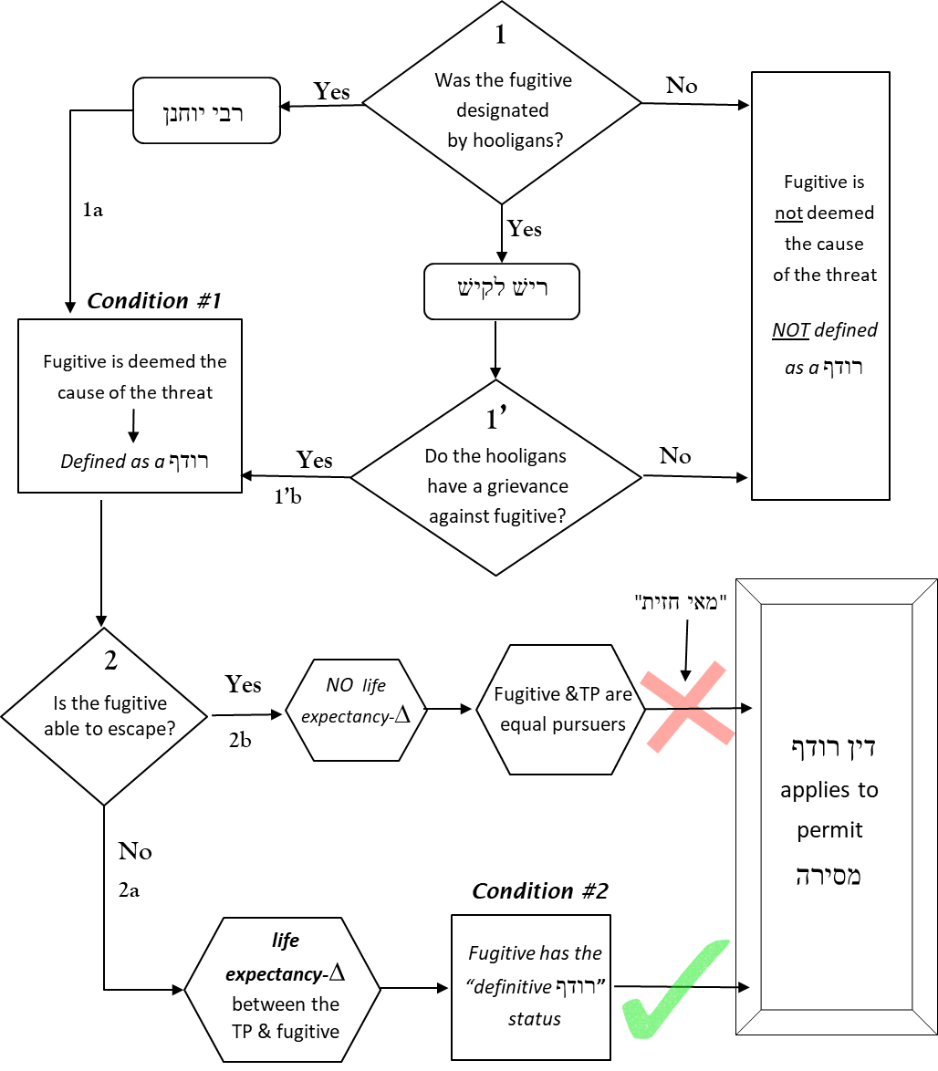

  - The רמב״ם (Source A-5) and the second opinion in the רמ״א (Rav Moshe Isserles, Supplement 1, Source 9a, p. 57) follow the position of רישׁ לקישׁ who requires a “death sentence” (i.e., the hooligans’ grievance against this fugitive, according to Rav Moshe’s interpretation) to permit מסירה. This poses a difficulty for the suggestion that MPR could be permitted based on the דין רודף (Section VIII, pp. 27-30). Certainly, no fetus in the MFP situation has a death sentence or a grievance against him. According to the רמב״ם and the רמ״א, how could the דין רודף be applied to permit MPR?
Source A-5: The רמב״ם follows ריש לקיש’s position regarding handing over the fugitive.
Similarly, if gentiles told [a group of Jews], “Give us one of you and we will kill him; and if not, we will kill all of you”: Let them all be killed and they may not give over one Jewish life to them. However, if they designated someone and said, “Give us so-and-so, or we will kill all of you”: If the person is liable to the death penalty like שבע בן בכרי, they may give him over to them. However, at the ideal level of Halacha (לכתחלה), this instruction is not conveyed to them. If he is not liable to the death penalty, let them all be killed and they may not give over one Jewish life to them. | רמב״ם פרק ה׳ הלכות יסודי התורה, הלכה ה׳:  וכן אם אמרו להם עובדי כוכבים תנו לנו אחד מכם ונהרגנו ואם לאו נהרוג כולכם, יהרגו כולם ואל ימסרו להם נפש אחת מישראל. ואם יחדוהו להם ואמרו תנו לנו פלוני או נהרוג את כולכם, אם היה מחויב מיתה כשבע בן בכרי יתנו אותו להם, ואין מורין להם כן לכתחלה. ואם אינו חייב מיתה יהרגו כולן ואל ימסרו להם נפש אחת מישראל.

  - Perhaps we can answer this question based on Rav Moshe’s understanding that the only reason רישׁ לקישׁ requires a “death sentence” is to define the fugitive as the cause of the threat (“הסבה להרדיפה”) confronting the townspeople and thus, define him as a רודף (see paragraphs D-E, p. 36). In the fugitive situation, there is no inherent basis for any one person to be considered as the cause of the threat even if he was designated because the entire origin of the crisis (i.e., the hooligans) was externally imposed (according to Rav Moshe’s understanding that רישׁ לקישׁ’s ruling is unrelated to any culpability of the fugitive). Thus, we need some method to discern that this fugitive is considered the cause of the threat. The “death sentence”, unjust as it may be, serves to define him as the cause of the threat since it demonstrates that the hooligans specifically selected this individual and they will not be assuaged by handing over anyone else. As an illustration of this notion, Rav Moshe notes that רישׁ לקישׁ will agree with רבי יוחנן that a grievance is not required if other situational details demonstrate that the fugitive is the cause of the threat, e.g., if the fugitive was designated before he fled to their city, the townspeople may hand him over even without a grievance (see paragraph G, p. 37).
  - By contrast, in the MFP situation, the cause of the danger is internally imposed, i.e., it is evident that the fetuses themselves are the origins of the threat and therefore, we do not require any external imposition of a “death sentence” to define any fetus as a רודף. Therefore, the dispute between רבי יוחנן andרישׁ לקישׁ as to whether the mere designation by the hooligans without a “death sentence” suffices to define the fugitive as the רודף, is not germane to the MFP situation.
  - In summary, the Chasdei Dovid and Rav Moshe offer two different explanations for the permissibility for מסירה (i.e., to hand over the designated fugitive) if the townspeople will be killed if he is not turned over:
    - According to the Chasdei Dovid, the permissibility for מסירה is because the “מאי חזית” logic does not apply, as follows:
      - If the fugitive does not deserve the death penalty, but he and townspeople have no escape capability, מסירה is permitted “because the reason of ‘מאי חזית’ does not apply when they all are in an equal state of danger” (Source 12, p. 12).
      - If the fugitive deserves the death penalty (חייב מיתה), even if he can escape, מסירה is permitted “because the logic of ‘מאי חזית’ does not apply when he is חייב מיתה” (Supplement 1, Source 5, p. 54).
    - However, according to Rav Moshe, the permissibility for מסירה is because the fugitive is considered a רודף after the townspeople since he is the cause of their impending doom (“הסבה להרדיפה”). Both רבי יוחנן and רישׁ לקישׁ agree that this applies: (1) only if the fugitive has no escape capability; and (2) even if the fugitive does not deserve the death penalty through a legitimate justice system. רבי יוחנן and רישׁ לקישׁ merely disagree as follows:
      - רבי יוחנן believes that merely by being designated, the fugitive is the cause of their impending doom, conferring upon him the status of a רודף and therefore, he may handed over; whereas
      - רישׁ לקישׁ believes only if the hooligans have a grievance against this fugitive for which they wish to kill him, he cause of their impending doom and has the status of a רודף.
  - The two approaches we offered for potentially permitting MPR if there is a high probability of total fetal death (VII-2, pp. 25-26), may well align well with these two approaches for the permissibility for מסירה. According to the Chasdei Dovid who states that the “מאי חזית” logic does not apply if everyone is in equal danger, perhaps MPR can be permitted because the “מאי חזית” logic will not apply if all the fetuses will likely die without intervention. This approach was suggested by Rabbi Dr. Zalman Levine. However, according to Rav Moshe who considers the fugitive as a רודף even without any culpability simply because he is the cause of another’s impending doom, perhaps MPR can be permitted because each fetus is a רודף after the others. This approach of Rav Shlomo Zalman Auerbach was recorded by Rabbi Dr. Abraham (Source 19, p. 26).

