Table of Contents
Section | Title | Page
I | Introduction | 1
II | Two approaches to potentially permit multifetal pregnancy reduction | 2
III | The “obstructed labor” situation: When can the mother be saved at the expense of the fetus’ life? | 7
IV | The “fugitive” situation: When can the townspeople save themselves at the expense of the fugitive’s life? | 9
V | Reason for the difference within the two obstructed labor and the two fugitive situations (Approach 1) | 11
VI | Reason for the difference within the two obstructed labor and the two fugitive situations (Approach 2) | 14
VII | Application of אין דוחין נפשׁ מפני נפשׁ and רודף דין to the multifetal pregnancy situation | 25
VIII | Possible approach to permitting multifetal pregnancy reduction based on Rav Moshe Feinstein’s explanation of the רודף דין | 27
IX | Conclusion | 32
X | References | 34
Appendix A | The Views of רבי יוחנן and רישׁ לקישׁ Regarding the “Fugitive” Situation, in the Talmud Yerushalmi | 35
Appendix B | Rashi’s View of the מאי חזית Logic in the “Coerced Murder” Case, as Explained by Rav Moshe Feinstein | 43
Appendix C | Medical Facts Relevant to Multifetal Pregnancies and Multifetal Reduction | 50
Appendix D | אין דוחין נפשׁ מפני נפשׁ: Rav Moshe Feinstein’s Explanation of Rashi | LI

לעילוי נשמת אחי ורבי הרב ישראל יוסף אליהו בן ר׳ טוביה הלוי זצ״ל
ולעילוי נשמת ר׳ יצחק בן יהודה ז״ל
Note: This Shiur it is not intended as a source of practical Halachic (legal) rulings. For matters of Halacha (practical details of Jewish law), please consult a qualified Posek (rabbi).

Table of Sources - מקורות
Source No. | Pages No. | Source | Source Subject
1 | 2 | גמרא, מס׳ סנהדרין, דף עד ע״א | יהרג ואל יעבור
2 | 3 | גמרא, מס׳ יומא, דף פב ע״ב | יהרג ואל יעבור - לא תרצח
3 | 4 | רש״י מס׳ סנהדרין, דף עד ע״א | יהרג ואל יעבור - לא תרצח
4 | 4 | ויקרא פרק יח: ה ;יומא דף פה ע״א | The “וחי בהם”-dispensation
5 | 6 | משנה, מס׳ סנהדרין, דף עג ע״א | דין רודף
6 | 7 | משנה, מס׳ אהלות ,פרק ז׳: ו׳ | The “Obstructed Labor” Situation
7 | 8 | גמרא, מס׳ סנהדרין, דף עב ע״ב | משׁמיא קא רדפי לה
8 | 8 | מנחת חינוך, מצוה רצו | יהרג ואל יעבור - לא תרצח
9 | 9-10 | תוספתא, מס׳ תרומות, פ״ז ה״כ | The “Fugitive” Situation
10 | 10 | ירושלמי, מס׳ תרומות, פ״ח ה״ד | The “Fugitive” Situation
11a-b | 11 | רש״י, מס׳ סנהדרין, דף עב ע״ב  )סמ"ע על שלחן ערוך חושן משפט( | The “Obstructed Labor” Situation
12 | 12 | חסדי דוד על תוספתא תרומות | The “Fugitive” Situation
13 | 14 | רמב״ם, הל׳ רוצח פ״א, ה״ט | The “Obstructed Labor” Situation
14 | 16 | אגרות משה, חושן משפט ח״ב, סימן עא׳ | The “Obstructed Labor” Situation
15 | 17 | אגרות משה, יורה דעה ח״ב, סימן ס׳ | Fugitive and Obstructed Labor Situations
16 | 17 | ירושלמי, מס׳ שבת, פ״ד ה״ד | The “Obstructed Labor” Situation
17 | 21 | אגרות משה, יורה דעה ח״ב, סימן ס׳ | The “Obstructed Labor” Situation
18 | 21 | אגרות משה, יורה דעה ח״ב, סימן ס׳ | The “Fugitive” Situation
19 | 26 | נשמת אברהם, חושן משפט, סימן תכה׳ | P’sak of Rav Shlomo Zalman Auerbach  regarding MPR

- Introduction
The focus of this presentation is to explore the possible approaches for permitting multifetal pregnancy reduction (abbreviated as: MPR) in Halacha, by applying the teachings of the Talmud (Mishna, Braita and Gemara), post-Talmudic commentators and Poskim (Halachic authorities).
Multifetal pregnancies (abbreviated as: MFP) are associated with several risks including complete pregnancy loss (miscarriage and stillbirth) and very preterm birth (i.e., occurring before 32 completed weeks of gestation) which is often complicated by postnatal mortality (i.e., death after birth) and long-term disabilities. MPR is a procedure performed by obstetricians to reduce the number of fetuses in utero in a MFP, to improve the survival probability of the remaining fetuses. Reducing the number of fetuses leads to improved outcomes, as measured by lower rates of miscarriage, fewer very preterm births and reduced postnatal mortality (see Appendix C, p. 50). MPR is usually performed between 9 to 15 weeks of gestational age. Historically, MPR has been generally performed in triplet or higher-order pregnancies; however, cases of twin to singleton pregnancy reductions have also been reported.
It is understood that the goal of MPR is to optimize the survival chances of the remaining fetuses in cases where there is a high risk of fetal death without intervention. Yet, since MPR, by definition, terminates one or more fetal lives, contemporary Poskim and religious physicians have endeavored to understand how Halacha views this predicament. This dilemma falls into the rubric of a general question: Can we end one life to save another life? Generally, taking a life cannot be justified even if it is the sole means for promoting the survival of another life. This principle is described in Tractate Oholot as: אין דוחין נפשׁ מפני נפשׁ (which will henceforth be referred to as: “אין דוחין”), i.e., we may not push aside one life on account of another life. Nonetheless, in very limited applications discussed below, we are instructed to save a life even if this will lead to the demise of another life. The following discussion describes selected applications and limits of אין דוחין נפשׁ מפני נפשׁ and their relevance to the potential permissibility of MPR.
In the course of this discussion, we will explore two different approaches for permitting MPR in cases where the failure to intervene will lead to a high risk of total fetal/neonatal death (i.e., death either in utero or shortly after birth). One approach is derived from the discussion in the Talmud concerning the ruling that one must give up his or her life not to commit murder: יהרג ואל יעבור (i.e., be killed rather than transgress). Perhaps the basis for the יהרג ואל יעבור ruling, which the Talmud describes as a logical reasoning that one may not presume one life is more valuable than any other life, may not apply in a case of multifetal pregnancy if the fetuses are likely to perish without intervention. If this is true, perhaps the principle of
אין דוחין also will not apply under these conditions and MPR may therefore, be permitted. The second approach for permitting MPR is the דין רודף (i.e., the law of the pursuer) which states that the life of a pursued person must be saved even at the expense of the pursuer’s life. According to this approach, the fetuses that will be reduced (i.e., aborted) are considered as “pursuers” after the other fetuses. We develop this approach through the brilliant writings of the Gaon and Tzaddik, Rav Moshe Feinstein, זצ״ל, (who was a leading Halachic decisor, Posek, spanning a half-century period in America, who will henceforth be referred to as: “Rav Moshe”) in his magnum opus, Igros Moshe. These approaches are built on two Talmudic cases, the “obstructed labor” and the “fugitive” situations, which will be explained below with different interpretations and their applications to MPR.
- Two approaches to potentially permit multifetal pregnancy reduction:
Notwithstanding the general principle of אין דוחין, we will examine two approaches that could be applied to permit MPR in certain cases. These approaches, which originate from two different “life-vs.-life” discussions in the Talmud, will be referred to as: 1) the מאי חזית logic; and 2) the דין רודף.
  - The “coerced murder” case and the מאי חזית logic:
Definitions:
α: The coerced person: The Jewish person who was ordered by the governor (i.e., the hooligan) to kill another Jew (β) under the threat of being killed if he refused.
β: The hooligan’s target: The person who α was ordered to kill.
    - The Gemara Sanhedrin (Source 1) states that שׁפיכת דמים (murder, i.e., violating the prohibition of לא תרצח, “do not commit murder”), is one of the three prohibitions for which one must sacrifice his or her own life rather than transgress. This ruling is called יהרג ואל יעבור.
Source 1: Talmud Bavli - Sanhedrin 74a: Three cases where Halacha requires one to sacrifice his life to avoid transgressing – (יהרג ואל יעבור).
רבי יוחנן said in the name of רבי שמעון בן יהוצדק: They took a vote and decided in the attic of Nitzah’s home in Lod: Concerning all prohibitions in the Torah, if they tell a person, “transgress and you will not be killed [but if you refuse to do so, we will kill you],” he should transgress and not allow himself to be killed, except for idol worship, illicit relations and murder (for which a person must sacrifice his life rather than transgress). | סנהדרין דף עד עמוד א:  אָמַר רַבִּי יוֹחָנָן מִשּׁוּם רַבִּי שִׁמְעוֹן בֶּן יְהוֹצָדָק נִמְנוּ וְגָמְרוּ בַּעֲלִיַּת בֵּית נִתְּזָה בְּלוֹד: כָּל עֲבֵירוֹת שֶׁבַּתּוֹרָה אִם אוֹמְרִין לָאָדָם עֲבוֹר וְאַל תֵּהָרֵג יַעֲבוֹר וְאַל יֵהָרֵג, חוּץ מֵעֲבוֹדַת כּוֹכָבִים וְגִלּוּי עֲרָיוֹת וּשְׁפִיכוּת דָּמִים.
    - The Gemara (Source 2) states that the Rabbis deduced the Halacha of יהרג ואל יעבור with respect to שׁפיכת דמים (murder), through a logical reasoning (סברא), for which theגמרא recounts a true incident: The governor ordered person “α” to kill person “β” or else the governor would kill α. (This case will henceforth be called the “coerced murder” case). רבא (or רבה) ruled that α must be killed rather than kill β because of the following logic: “מאי חזית דדמא דידך סומק טפי דילמא דמא דההוא גברא סומק טפי” - “Why do you presume that your blood is redder? Maybe that man’s blood is redder.” This reasoning will henceforth be called the “מאי חזית logic”.
Source 2: Talmud Bavli - Yoma 82b: Reason for the יהרג ואל יעבור ruling in the “coerced murder” case:
The מאי חזית logic.
From where do we know that a person must sacrifice his life rather than commit murder? It is based on logic (סברא) [as we see from the following incident]: A certain person (α) came before רבא and told him, “The governor of my village said to me, ‘Go kill So-and-so (β), and if you do not [kill him], I will kill you.’” רבא replied to him (α), “Let him kill you and do not kill (β). Why do you presume that your blood is redder [than β‘s blood]? Perhaps the blood of that man (β) is redder.” | יומא דף פב, עמוד ב:  וְרוֹצֵחַ גוֹפֵיה מְנָא לָן ? סְבָרָא הִיא. דְהַהוּא דְּאָתָא לְקַמֵיהּ דְרָבָא וְאָמַר לֵיה אָמַר לִי מָרִי דוּרָאי זִיל קַטְלֵיה לִפְלָנְיָא וְאִי לֹא קַטְלִינָא לָךְ. אָמַר לֵיה לִקְטְלוּךְ וְלֹא תִּקְטוֹל. מַאי חָזִית דְדְמָא דִידָךְ סוּמָק טְפֵי דִילְמָא דָמָא דְהַהוּא גַבְרָא סוּמָק טְפֵי ?
    - What is the meaning of the מאי חזית logic and how does it dictate the Halacha of יהרג ואל יעבור by שׁפיכת דמים (the “coerced murder” case)? The following two approaches are presented:
      - Approach 1: The מאי חזית logic operates from a perspective of uncertainty, i.e., since we do not know whose life is considered more valuable, the uncertainty dictates that one must maintain a passive stance (שב ואל תעשה) to avoid arbitrarily selecting who should be allowed to live versus who should be killed, even at the pain of his own death (Talmeidai Rabbeinu Yonah, Reference 1; see also p. 45, Source B-2). Rav Nochum Partzovitz (Reference 2) attributes this approach to Tosfot in Sanhedrin 74b.
According to this approach, in cases of MFP where there is a high risk of total fetal/neonatal death, an argument could be made to permit MPR. Since the fetuses that would be reduced (i.e., aborted) via the MPR procedure would likely die anyway if we remained passive, perhaps it is not considered selecting them for death and therefore, the מאי חזית logic would not apply. This will be discussed further below (see VII-2-C, p. 25).
      - Approach 2: Rashi (Source 3) explains that although the גמרא derives the principle that מצות are pushed aside for the preservation of life from the words “וחי בהם” (Vayikra 18:5, “and he shall live by them”, Source 4), this “וחי בהם-dispensation” does not extend to the prohibition against murder because of the מאי חזית logic: If α would murder β to save his own life, the intent of the “וחי בהם-dispensation”, i.e., preservation of a Jewish life, cannot be fulfilled because a Jewish life (β’s life) will be lost through the very violation of the מצוה (i.e., transgression of לא תרצח). In the absence of the “וחי בהם-dispensation”, the מצוה must be observed even at the cost of his (α’s) own life. (See Figure 1, p. 5 for a schematic diagram of Rashi’s explanation). Rav Moshe, when discussing this Rashi, adds, “Therefore, we infer [from Rashi] that with regard to this דין [of יהרג ואל יעבור], his (α’s) life and the life of his friend (β) are equal” (Reference 3). Possibly, Rav Moshe inferred the equality of both lives (α and β) from Rashi’s explanation that the intent of the “וחי בהם-dispensation” is negated when the preservation of one life is neutralized by the destruction of another equally valued life (see Appendix B, pp. 43-49, for further aspects of Rashi’s view of the
מאי חזית logic, with Rav Moshe’s explanation).
Source 3: Rashi’s explanation of the מאי חזית logic: Inapplicability of the “וחי בהם-dispensation” in the “coerced murder” case (Talmud Bavli - Sanhedrin 74a):
רש״י ,סנהדרין דף עד ע״א, ד”ה סברא הוא:
[The logic is]: α may not push aside his friend (β’s) life which entails two [negative consequences, “תרתי”], a loss of (β’s) life and transgression of an עבירה (i.e., לא תרצח), in order to save himself [from being killed] which would only entail one [negative consequence, “חדא”], a loss of (α’s) life, but he will not transgress (לא תרצח). | שלא תדחה נפש חבירו דאיכא תרתי אבוד נשמה ועבירה מפני נפשו דליכא אלא חדא אבוד נשמה והוא לא יעבור.
The Torah only permitted us to violate מצות based on the “וחי בהם-dispensation” because a Jewish life is precious in the eyes of Hashem. | דכי אמר רחמנא לעבור על המצות משום וחי בהם משום דיקרה בעיניו נשמה של ישראל.
However, here, regarding [the transgression of] murder, [i.e., if α kills β, the “וחי בהם-dispensation” will not apply for the following reason]: Since a life will be lost in any event, why should it be permitted to transgress? | והכא גבי רוצח כיון דסוף סוף איכא איבוד נשמה למה יהא מותר לעבור ?
Who says (literally: who knows) that your (α’s) life is dearer to Hashem than your friend (β’s) life? | מי יודע שנפשו חביבה ליוצרו יותר מנפש חבירו ?
Therefore, the word of Hashem (לא תרצח) may not be pushed aside. | הלכך דבר המקום לא ניתן לדחות.
Source 4: Basis for the dispensation to suspend nearly all מצות for the preservation of human life:
The “וחי בהם-dispensation” (Vayikra 18:5 and Talmud Bavli - Yoma 85b).
You shall observe my statutes and ordinances which a man shall do and live by them, I am Hashem. | ויקרא פרק יח: פסוק ה:  וּשְׁמַרְתֶּם אֶת חֻקֹּתַי וְאֶת מִשְׁפָּטַי אֲשֶׁר יַעֲשֶׂה אֹתָם הָאָדָם וָחַי בָּהֶם אַנִי יקוק.
Rav Yehuda said in the name of Shmuel: The words “וחי בהם” teach us that he shall live by them (the מצות) and he shall not die by them. | יומא דף פה עמוד ב:  אמר רב יהודה אמר שמואל …וחי בהם ולא שימות בהם.
Figure 1: Rashi explains the מאי חזית logic as the basis for יהרג ואל יעבור in the “coerced murder” case:
The “וחי בהם-dispensation” is inapplicable.
If α would murder β to save his own life (Option 1), there would be two negative consequences: the loss of a life (β’s life) and violation of a מצוה (i.e., transgression of לא תרצח). On the other hand, if α remains passive (Option 2), only one negative consequence would occur: the loss of α’s life, but no מצוה will transgressed. The reason for the “וחי בהם-dispensation” is that a Jewish life (נפש ישראל) is dearer to Hashem than His מצות and thus, He prefers to forego His מצות in favor of preserving a נפש ישראל. However, here, since a life (β) will be lost in end, why should Hashem be willing to forego his מצוה (i.e., why should He allow α to transgress לא תרצח)?
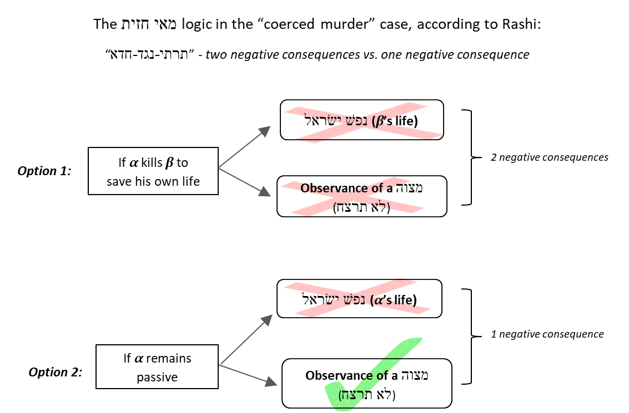
“”: Denotes the loss of a Jewish life (נפש ישראל) or a violation of a מצוה.
“”: Denotes the fulfillment of a מצוה.

  - Concept of Pursuer - The דין רודף (Source 5):
Definitions:
רודף - Pursuer: Person who endangers the life of a prospective victim.
נרדף - Pursued person: The prospective victim, whose life is endangered by the רודף.
    - A pursuer who attempts to kill a prospective victim is called a רודף. The Torah authorizes the נרדף or anyone else to preemptively take the רודף’s life to save the נרדף. This is called the דין רודף.
Source 5: Mishna - Sanhedrin 73a: The דין רודף: Saving the intended victim by killing the pursuer.
These are to be saved at the cost of their (attackers’) lives: One pursuing his fellow man to kill him … | סנהדרין דף עג, עמוד א:  וְאֵלּוּ הֵן שֶׁמַּצִּילִין אוֹתָן בְּנַפְשָׁן הָרוֹדֵף אַחַר חֲבֵירוֹ לְהָרְגוֹ…
    - For the purposes of this discussion, we will divide pursuers (רודפים) into two categories:
      - Intentional רודף: This category refers to the classic pursuer who intends to kill or endanger another person. This category may perhaps be expanded to a situation where a person displays blatant disregard for another’s life by engaging in an activity with the awareness that it may result in a loss of life even if his goal is not to bring about someone’s death.
      - Unintentional רודף: This category refers to a pursuer who has no intention to endanger anyone, but nonetheless unwittingly poses a threat to another’s life. This type of pursuer may be a passive participant in a process that leads to endangerment of another person, without knowledge nor intent of any potential harmful consequences.
    - There are two approaches, as to whether the דין רודף applies only to (permit killing) intentional pursuers or to both intentional and unintentional pursuers.
      - Intentional pursuit only: According to the Dina Dechayei (authored by Rav Chaim Benveniste, Reference 4) and the Minchat Chinuch (authored by Rav Yosef Babad, Source 8, p. 8), the דין רודף only applies to cases of intentional pursuit.
      - Intentional and unintentional pursuit: According to the Chazon Ish (authored by
Rav Avrohom Yeshaya Karelitz, Reference 5; see pp. 57-58) and Rav Moshe (Source 15, p. 17), the דין רודף applies to cases of both intentional and unintentional pursuit.
    - According to the position that the דין רודף applies even to unintentional pursuit, in cases of MFP where there is a high risk of total fetal/neonatal death, perhaps it would be permitted to reduce one or more of fetuses based on the premise that they pursue after the other fetuses. This will be discussed further below (see VIII, 2-7, pp. 27-30).
- The “obstructed labor” situation: When can the mother be saved at the expense of the fetus’ life?
  - Mishna, Tractate Oholot (Source 6): ‘non-emerged fetus’ vs. ‘partially-emerged fetus’
This Mishna discusses the case of a woman in mortal danger during obstructed labor. The only way to save her life would be to dismember and remove the fetus. Before the fetus’ head has emerged (henceforth described as the ‘non-emerged fetus’), the fetus should be cut out (i.e., killed) to save his mother’s life. The Mishna’s reason to permit sacrificing the fetus is “because her life takes precedence over his life”. However, after the emergence of fetus’ head (henceforth described as the ‘partially emerged fetus’), we must allow the childbirth to proceed although the mother will die, because of the principle of אין דוחין, i.e., we may not push aside the fetus’ life to save his mother.
Source 6: Mishna - Oholot 7:6: “Obstructed labor” situation:
Source for the permissibility to save the mother at the expense of the unborn fetus.
A woman who Is having difficulty giving birth (and her life is endangered), we cut the fetus within the womb and remove him limb-by-limb, because her life has precedence over his life. However, if his (i.e., the fetus’) *head has emerged, we may not touch (i.e., kill) him, because we may not push aside one life on account of another life.  *According to the text in Talmud Bavli - Sanhedrin 72b | אהלות פרק ז, משנה ו:  הָאִשָּׁה שֶׁהִיא מַקְשָׁה לֵילֵד, מְחַתְּכִין אֶת הַוָלָד בְּמֵעֶיהָ וּמוֹצִיאִין אוֹתוֹ אֵבָרִים אֵבָרִים מִפְּנֵי שֶׁחַיֶּיהָ קוֹדְמִין לְחַיָּיו. יָצָא *רֹאשוֹ, אֵין נוֹגְעִין בּוֹ לְפִי שֶׁאֵין דּוֹחִין נֶפֶשׁ מִפְּנֵי נֶפֶשׁ.
Table 1: Summary of the “obstructed labor” situation. Whose life is spared: the mother or the fetus?
Case | Description | What is the Halacha? | Whose life is spared? | Reason stated in the Mishna
‘non-emerged fetus’ | Fetus is still totally in utero | Cut out the fetus | Mother | The mother’s life has precedence over the fetus’ life
‘partially-emerged fetus’ | Fetus’ head has emerged  during birth process | Remain passive | Fetus | We may not push aside one life to save another life
  - Gemara (Talmud Bavli) - Sanhedrin 72b (Source 7):
In this Gemara, רב הונא states that a child pursuer may be killed to save his prospective victim. רב חסדא posed the following challenge to רב הונא from the above Mishna in Oholot: Since the Mishna rules that we may not kill the ‘partially emerged fetus’ to save his mother even though he is the cause of her endangerment, it is apparent that the דין רודף is not applied to kill a child pursuer? The Gemara answers, “דמשׁמיא קא רדפי לה התם שאני”– “That (obstructed labor) case is different because she is being pursued by Heaven.” Two explanations of the Gemara’s answer are presented:
    - The Minchat Chinuch (Source 8), who believes the דין רודף does not apply in cases of unintentional pursuit, understands the phrase, “משׁמיא קא רדפי לה” - she is pursued by Heaven - to mean that, in fact, the ‘partially emerged fetus’ is not considered a רודף because physiology (childbirth), rather than volition, has endangered his mother’s life (per Rabbi Dr. Zalman Levine, Reference 6). Accordingly, the Gemara answers the above question on רב הונא by differentiating between the child pursuer and the ‘partially emerged fetus’, i.e., the דין רודף applies to the former case because the child pursuer intends to kill his prospective victim but not to the latter case because the emerging fetus lacks volition.
    - The explanation of the Gemara’s answer, according to Rav Moshe Feinstein, will be discussed below (VI, 4-6, pp. 14-17).
Source 7: Talmud Bavli - Sanhedrin 72b: Does the דין רודף apply to a child pursuer?
Source of the משׁמיא קא רדפי לה concept.
רב הונא said, If a child pursues his fellow, (the fellow) may be saved at the cost of the child’s life .... רב חסדא posed a question to רב הונא [from a Mishnah]: “If his (the fetus’) head has emerged we may not touch him for we may not push aside one life on account of another person’s life.” But why not kill the fetus – he is a רודף (pursuer)? [The Gemara answers]: That [obstructed labor case] is different because she (i.e., the mother) is being pursued by Heaven. | תלמוד בבלי סנהדרין דף עב, עמוד ב:  אָמַר רַב הוּנָא קָטָן הָרוֹדֵף נִיתָּן לְהַצִּילוֹ בְּנַפְשׁוֹ. .... אֵיתִיבֵיה רַב חִסְדָא לְרַב הוּנָא יָצָא רֹאשׁוֹ אֵין נוֹגְעִין בּוֹ לְפִי שֶׁאֵין דוֹחִין נֶפֶשׁ מִפְּנֵי נֶפֶשׁ. וְאַמַאי רוֹדֵף הוּא ? שַׁאנִי הָתָם דְּמִשְׁמַיָּא קָא רָדְפֵי לָהּ.
Source 8: Minchat Chinuch, Mitzvah 296: The דין רודף does not apply to unintentional pursuit.
(See Supplement 1, Source 3, p. 52, for a more extensive excerpt from the Minchat Chinuch).
The Gemara in Sanhedrin states that a child pursuer may be killed to save his prospective victim. The Gemara asked from the Mishna in Oholot, “... If his head has emerged, we may not touch him because we may not push aside one life on account of another life. But - why not kill the fetus – he is a רודף?” The Gemara answered, “that [obstructed labor case] is different because she is being pursued from Heaven.” Hence, the fetus is not a רודף and it is forbidden to save one life by taking another life since [the transgression of] murder is not pushed aside [to save a life]. | מנחת חינוך, מצוה רצו:  דהנה מבואר בסנהדרין שם דאף קטן הרודף ניתן להצילו בנפשו. ומקשה הש״ס ממשנה דאהלות … יצא ראשו, אין נוגעין בו מפני שאין דוחין נפש מפני נפש. ואמאי הא הוי ליה רודף? ומשני הש״ס שאני התם דמשׁמיא קא רדפי לה, ואם כן לא הוי רודף ואסור להציל נפש עם נפש אחר כי שפיכת דמים אינו נדחה.

- The “fugitive” situation: When can the townspeople save themselves at the expense of the fugitive’s life?
Defintions:
Fugitive: Refers to the individual hiding in the city that the hooligans wish to kill. The hooligans order the townspeople to hand the fugitive over to them.
Townspeople: Refers to the remainder of the people in the city who are ordered by the hooligans to either hand over the fugitive or else they will all be killed.
מסירה: Refers to the act of handing over a Jew to the gentiles.
  - The Tosefta in Terumot (Source 9) discusses a case in which a group of people (i.e., ‘townspeople’) are surrounded by hooligans who demand they hand over an individual (i.e., a ‘fugitive’) to be killed or else they will all be killed. The Tosefta and the Yerushalmi - Terumot (Source 10) distinguish between a case where the hooligans designate (i.e., single out) a specific victim to be delivered to them versus a case where they simply demand that the townspeople hand over any person to them. If the hooligans do not designate a specific victim, it is forbidden for the townspeople to hand over anyone even though everyone will then be killed. However, if the hooligans designate a specific victim to be handed over, under specified conditions, the townspeople may hand him over to save themselves. The paradigm presented by the Tosefta is the episode of שבע בן בכרי (ש.ב.ב) in Shmuel II, Ch. 20. After ש.ב.ב, a fugitive from justice for leading a revolt against דוד המלך, took refuge in the city Avel, the townspeople delivered him to יואב’s sieging army, thereby saving the lives of all the townspeople who otherwise would have been killed when the army invaded the city. Clearly, ש.ב.ב was a designated fugitive (and was liable to the death penalty for rebelling) as יואב stated, (ibid, verse 21) “ש.ב.ב has lifted his hand against the king, against David; give us him alone and I will depart from the city.”
Source 9: Tosefta Terumot 7:20: “Fugitive” situation (Explanation is based on the Eitz Yosef on Bereishis Rabboh, 94).
תוספתא מסכת תרומות פרק ז הלכה כ(See Supplement 1, Source 4, p. 53, for a more extensive explanation) :’
If a group of people [were accosted by] gentiles who said to them, “Give us one of you and we will kill him; and if not, we will kill all of you,” [the ruling is]: Let them all be killed, and they may not give over one Jewish life to them. | סיעה של בני אדם שאמרו להם גוים תנו לנו אחד מכם ונהרגהו ואם לאו הרי אנו הורגין את כולכם יהרגו כולן ואל ימסרו להן נפש אחת מישראל.
But if the gentiles designated someone (i.e., a ‘fugitive’) in the manner that they designated ש.ב.ב, they should hand him over rather than all being put to death. | אבל אם ייחדוהו להם כגון שייחדו לשבע בן בכרי, יתנו להן ואל יהרגו כולן.
רבי יהודה said, when does this apply (i.e., they may not hand him over)? Only if the fugitive is in the exterior [and he can escape] while the townspeople are in the interior [and are unable to escape]. However, if all of them are in the interior since [no one can escape and consequently] they will all be killed, they should hand him over to them rather than all being put to death. | אמר רבי יהודה במה דברים אמורים בזמן שהוא מבחוץ והן מבפנים. אבל בזמן שהוא מבפנים והן מבפנים הואיל והוא נהרג והן נהרגין, יתנוהו להן ואל יהרגו כולן.
As it states, “And the woman approached all the people with her wisdom” (Shmuel II, Ch. 20, v. 22). She said to them, “Since he will be killed and you will be killed, give him over to them so that all of you will not be killed.” | וכן הוא אומר ותבא האשה אל כל העם בחכמתה. אמרה להן הואיל והוא נהרג ואתם נהרגין תנוהו להם ואל תהרגו כולכם.
רבי שמעון said, so she said to them, “Anyone who rebels against the kingdom of David, is liable to execution.” | רבי שמעון אומר כך אמרה להם כל המורד במלכות בית דוד חייב מיתה.
  - Yet, the hooligans’ designation of a specific victim (in most cases) is not sufficient to permit handing the fugitive over. In the Tosefta (Source 9, third statement), רבי יהודה states that the second requirement for permitting handover (מסירה) is that the fugitive must be unable to escape (‘fugitive without escape capability’) even if they do not hand him over. However, if the fugitive can escape (‘fugitive with escape capability’), it is forbidden to hand him over even though he was designated by the hooligans.
  - The permissibility of מסירה is subject to further dispute between רבי יוחנן andרבי שמעון בן לקיש (ריש לקיש) in the Talmud Yerushalmi (Source 10). ריש לקיש maintains that the designated fugitive must liable to the death penalty (חייב מיתה) in order to permit handing him over, whereas רבי יוחנן believes that even if the fugitive was not liable to the death penalty, it is permitted to hand him over. Refer to Appendix A (pp. 35-41) for an explanation of the positions of רבי יוחנן and ריש לקיש.
Source 10: Talmud Yerushalmi, Terumot 8:4: Fugitive situation: Dispute between רבי יוחנן and ריש לקיש.
We learned: If groups of people, who were traveling on the road, were accosted by gentiles who said, “Give us one of you and we will kill him; and if not, we will kill all of you,” [the ruling is]: Even if all of them will be put to death, they should not hand over [even] one person of Israel. But if the gentiles designated someone, as in the ש.ב.ב episode, they should hand him over and not get killed.  רבי שמעון בן לקיש said, This is providing he is liable to the death penalty like ש.ב.ב was. But רבי יוחנן said, This applies even if he is not liable to the death penalty like ש.ב.ב. | תלמוד ירושלמי תרומות פרק ח, הלכה ד׳:  תני סיעות בני אדם שהיו מהלכין בדרך, פגעו להן גוים ואמרו תנו לנו אחד מכם ונהרוג אותו ואם לאו הרי אנו הורגים את כולכם: אפילו כולן נהרגים לא ימסרו נפש אחת מישראל. ייחדו להן אחד כגון שבע בן בכרי ימסרו אותו ואל ייהרגו. אמר רבי שמעון בן לקיש והוא שיהא חייב מיתה כשבע בן בכרי. ורבי יוחנן אמר אף על פי שאינו חייב מיתה כשבע בן בכרי.

- Reason for the difference within the two obstructed labor and the two fugitive situations (Approach 1):
  - Obstructed labor situation: What is the reason that the mother’s life is prioritized only over the life of the ‘non-emerged fetus’, but not over the life of the ‘partially-emerged fetus’? The Sefer Meirat Einayim (סמ״ע; Source 11b) and the Minchat Chinuch (Supplement 1, Source 3, p.52) take the approach that the unborn (‘non-emerged’) fetus does not have the Halachic status of a living human being. These commentaries interpret Rashi’s statement regarding a fetus, “as long as he has not emerged into the air of the world, he is not a נפשׁ” (Source 11a), to mean that a fetus is not deemed a Halachic life. As such, feticide does not constitute שׁפיכת דמים (murder) and therefore, the fetus’ life may be pushed aside to save the mother, just as the imperative to save lives (פיקוח נפש) pushes aside all מצות (other than murder, idolatry and illicit relations). However, once the fetus’ head emerges, since he has the full Halachic status of a living being, killing him constitutes שׁפיכת דמים and therefore, we must remain passive so as not to push aside one life on account of another life.
Source 11a-b: Rashi in Sanhedrin (11a) and the Sefer Meirat Ainayim (סמ״ע) on Shulchan Aruch (11b):
Status of the ‘non-emerged fetus’ (See Supplement 1, Source 2, p. 51, for full text of Rashi):
רש״י סנהדרין דף עב׃ ד״ה יצא ראשו:  באשה המקשה לילד ומסוכנת. וקתני רישא החיה פושטת ידה וחותכתו ומוציאתו לאברים דכל זמן שלא יצא לאויר העולם לאו נפש הוא וניתן להורגו ולהציל את אמו. | Source 11a:  This is referring to a woman who is having difficulty giving birth and her life is endangered. The first section of the Mishna states that the midwife extends her hand, cuts him and removes him limb-by-limb. As long as he (i.e., the fetus) has not emerged into the air of the world, he is not a נפש (i.e., a life) and it is permitted to kill him to save his mother.
סמ"ע על שלחן ערוך חושן משפט סי׳ תכה ס״ק ח׳:  ואף על פי כן, בעודו במעיה מותר לחתכו אף על פי שהוא חי, שכל שלא יצא לאויר העולם אין שם נפש עליו, והא ראיה דהנוגף אשה הרה ויצאו ילדיה ומתו משלם דמי הולדות ואין שם רוצח ומיתה עליו. | Source 11b:  Nonetheless, while he is still in utero, it is permitted to dismember him even though he is alive because there is no name (i.e., status) of a נפש on him before he emerges into the air of the world. The proof is from the fact that one who strikes a pregnant woman aborting her pregnancy, must pay restitution for the fetuses, but there is no name of a murderer or death penalty upon him.
  - Fugitive situation: Why is it prohibited to hand over a ‘fugitive with escape capability’ while it is permitted to hand over a ‘fugitive without escape capability’? The Chasdei Dovid (authored by Rav Dovid Pardo, Source 12) explains this distinction based on the logic of מאי חזית. If the fugitive has the capability to escape, the townspeople have two theoretical options: (1) they could either allow the fugitive to escape and they will all be killed, or (2) they could save themselves by handing over fugitive to be killed. This is the standard מאי חזית dilemma, i.e., Why do you presume that the townspeople’s blood is redder than the fugitive’s blood? Accordingly, the townspeople must remain passive and allow the fugitive to escape. However, if the fugitive has no capability to escape, the מאי חזית logic does not apply since he cannot be saved even if the townspeople do not hand him over. Since the entire basis for the Halacha of יהרג ואל יעבור by שׁפיכת דמים is the מאי חזית logic, when the מאי חזית logic does not apply, i.e., if he is unable to escape, it is permitted to hand him over (See Supplement 2, p.46, paragraph 6a-b, for further explanation of the basis to permit מסירה).
Source 12: Chasdei Dovid on the Tosefta (Source 9): Basis for differentiating between the ‘fugitive with escape capability’ and the ‘fugitive without escape capability’: The מאי חזית logic.
(See Supplement 1, Source 5, p. 54, for a more extensive excerpt from the Chasdei Dovid).
When is it forbidden to hand over even a singled-out fugitive? ... [if the fugitive is in a location where] if the townspeople do not hand him over, they will be killed and he will escape. In such cases, even if the hooligans designated him, it is forbidden to hand him over because of the reason of מאי חזית (Why do you presume that the townspeople’s blood is redder than the fugitive’s blood?).  However, if everyone is in equal danger, i.e., they all are located in the inner sector … such that if the hooligans would come, they would kill the fugitive along with the townspeople – then, if the hooligans designated him, it is permitted [to hand him over] … because the מאי חזית logic does not apply when they all are in an equal state of danger. | חסדי דוד על תוספתא תרומות :  במה דברים אמורים שאסור על כל פנים למוסרו? ... שאם לא ימסרו אותו, הן נהרגים והוא נמלט, אז אפילו יחדוהו להם אסור מטעמא דמאי חזית דדמא דידך סומק טפי דילמא דמא דההוא גברא סומק טפי כדאמרינן בעלמא ...  אבל אם כולם שוין בסכנה כגון שכולם מבפנים ... שאם יבאו עכו״ם הורגים אותו ואותם, אז אם יחדוהו הוא דשרי ... דהא לא שייך טעמא דמאי חזית וכו׳ כשכולם שוין בסכנה.
    - This explanation fits well with the opinion of the Minchat Chinuch that מסירה is called
“אביזרא דשפיכת דמים” - i.e., an “ancillary form” of murder. Accordingly, just as the ruling of
יהרג ואל יעבור by שׁפיכת דמים is based on the מאי חזית logic, the ruling of יהרג ואל יעבור by מסירה is also based on the מאי חזית logic. Therefore, since the מאי חזית logic is inapplicable when the fugitive cannot escape, it is permitted to hand him over.
    - On a deeper level, the Chasdei Dovid’s understanding can be explained as follows: Perhaps the Halacha of יהרג ואל יעבור only dictates that one must remain passive (i.e., in the “coerced murder” case) when only one of the two parties will be killed and the only question is which of the two shall be killed. Since we don’t know whose life is more valuable, the מאי חזית logic dictates that we must remain passive rather than arbitrarily choosing one party to be killed. However, since the ‘fugitive without escape capability’ will be killed regardless of which option the townspeople choose, there is no reason to remain passive since we are not choosing any person for death. The only choice is whether to have all the townspeople killed along with the fugitive or to spare them, for which we may argue that מאי חזית does not pertain.

Table 2: Summary of Approach # 1 to explain the different rulings in the obstructed labor and fugitive situations:
Based on the position that an unintentional pursuer does not have a status of a רודף¹⁻².
Type of Situation | Sub-category | Who will be saved, as a consequence of choosing the ________ option? |  | Is the active option a  de facto selection?  who shall live vs. who shall die? |  | Is the active option considered שׁפיכת דמים (murder)? |  | Does the מאי חזית logic apply to forbid choosing the active option? |  | How does the Halacha decide?  which option?
 |  | ³Active | Passive | Yes/  No | Why | Yes/  No | Why | Yes/  No | Why?
Obstructed labor | non-emerged fetus | Mother | Fetus | Yes | By terminating the fetus, we are choosing that the mother, rather than the fetus, will live. | No | Since the fetus is not a ‘נפש’, feticide is not murder | No | מאי חזית only applies if the action is considered murder. | Active  (Feticide)
 | partially- emerged fetus | Mother | Fetus | Yes |  | Yes | The fetus now has a ‘נפש’ status | Yes |  | Passive
Fugitive | with escape capability | Towns-people | Fugitive | Yes | Fugitive will escape if we remain passive | Yes | מסירה is an  ²“ancillary form” of murder | Yes | מאי חזית only applies if the action selects who shall live vs. who shall die⁴. | Passive
 | without escape capability | Towns-people | No one | No | Fugitive will be killed even if we remain passive | Yes |  | No |  | Active  ⁵(מסירה)
¹Dina Dechayai (see Supplement 1, Source 6c, pp. 54-55)
²Minchat Chinuch (Source 8, p. 8)
³The active option is as follows: In the ‘obstructed labor’ situation: feticide; in the ‘fugitive’ situation: מסירה (handing him over).
⁴Based on the Chasdei Dovid (Source 12, p. 12)
⁵ריש לקיש maintains that מסירה is only permitted if there is a death sentence against the ‘fugitive without escape capability’.

- Reason for the difference within the two obstructed labor and the two fugitive situations (Approach 2):
This is one of the negative commandments not to take pity on the life of a pursuer. On this basis, our Sages ruled regarding a woman who is having difficulty giving birth (and her life is endangered), that it is permitted to cut out the fetus in utero, either medicinally or manually, because the fetus is considered a pursuer after her to kill her. However, if [the fetus’] head has emerged, we may not touch (i.e., kill) him since we may not push aside one life on account of another life and this is the natural order of the world. | רמב״ם, פרק א הל׳ רוצח ושמירת הנפש, הל׳ ט׳:  הרי זו מצות לא תעשה שלא לחוס על נפש הרודף. לפיכך הורו חכמים שהעוברה שהיא מקשה לילד מותר לחתוך העובר במיעיה בין בסם בין ביד מפני שהוא כרודף אחריה להורגה. ואם משהוציא ראשו, אין נוגעין בו שאין דוחין נפש מפני נפש וזהו טבעו של עולם.
  - According to Rav Moshe Feinstein and the other Halachic authorities who maintain that the דין רודף applies even to an unintentional רודף, both the fetus and the fugitive have the status of a רודף since they (albeit unintentionally) pose a danger to the mother or the townspeople, respectively. Accordingly, the permissibility to kill the ‘non-emerged fetus’ or to hand over the ‘fugitive without escape capability’ is based on the דין רודף. Rav Moshe (Reference 7), as well as Rav Chaim Soloveitchik (Reference 8) and Rav Elazar Menachem Man Shach (Reference 10), derive this approach from the Rambam (Source 13) who states that it is permitted to kill the ‘non-emerged fetus’ because he is considered a רודף after his mother.
Source 13: The Rambam’s view: The fetus is viewed as a רודף after the mother.
  - Rav Moshe deduces from the Rambam that a fetus is deemed a living being to the extent that feticide is included under the prohibition against murder (לא תרצח) unless the mother’s life is threatened. If feticide was not included under the prohibition of לא תרצח, it would not be necessary to invoke the דין רודף to authorize saving the mother at the fetus’ expense since all prohibitions (other than the three prohibitions mentioned above) are pushed aside for the sake of saving lives (פיקוח נפש).
  - However, according to this view, since intent is not needed to be considered a רודף, the ‘partially-emerged fetus’ should also be considered a רודף and therefore, should be killed to save his mother? What is the basis for the distinction in Halacha between the ‘non-emerged fetus’ and the ‘partially emerged fetus’? Similarly, if the basis for handing over the fugitive is his status as a רודף, why is there a distinction between a fugitive who can escape and a fugitive who cannot escape? In both cases, he endangers the lives of the townspeople and should be handed over to save them?
  - To explain Rav Moshe’s resolution of this dilemma, we must present his explanation of the phrase, "משׁמיא קא רדפי לה” - “she is being pursued by Heaven”, which the Gemara (Source 7, p. 8) states is the reason the ‘partially-emerged fetus’ must not be harmed even to save his mother. According to Rav Moshe’s explanation, the משׁמיא קא רדפי לה concept applies equally to the ‘partially-emerged fetus’ and ‘fugitive with escape capability’ cases. The following is the premise of his explanation:
    - The obstructed labor and fugitive situations are cases of “bidirectional pursuit”:
      - In the obstructed labor situation, the mother and fetus mutually pursue each other;
      - In the fugitive situation, the fugitive and townspeople mutually pursue each other.
Definition: “Rodef_{-א}” = fetus or fugitive and “Rodef_{-בּ}” = mother or townspeople
Note: The terms “opposing רודפים” or “opposing parties” denote a confrontation between “Rodef_{-א}” and “Rodef_{-בּ}”.
    - In the obstructed labor and fugitive situations, Heaven has arranged that there would be an “inverse relationship” between the respective survivals of Rodef_{-א} and Rodef_{-בּ} :
      - If the passive option is chosen, Rodef_{-א} will live and Rodef_{-בּ} will die;
      - Conversely, if the active option is chosen, Rodef_{-בּ} will live and Rodef_{-א} will die.
    - The reason why the fetus is considered a רודף despite having no intention to pursue or harm his mother, is because his only path to survival is by allowing the birth to proceed, which will cause his mother’s death. Similarly, the fugitive is considered a רודף because his only path to survival is by escaping, which will lead to the death of the townspeople.
    - One might ask, it is understandable that the fetus and fugitive are considered pursuers (רודפים) since their “arrival on the scene” threatens the lives of mother or townspeople, respectively. However, the mother and townspeople merely wish to defend themselves from the threat imposed on them. If so, how can they be defined as pursuers?
    - Rav Moshe writes (Source 14) that the message of משׁמיא קא רדפי לה is: Despite the fact that the mother’s life was not endangered until after the “arrival” of the fetus, we do not view the fetus as a unilateral רודף. Rather, Heaven ordained the “arrival” of the fetus with the purpose that both he and his mother would live, and only after this, the situation of danger befell both equally. My limited understanding of Rav Moshe’s explanation is: Since Heaven designed the (obstructed labor or fugitive) situation with an inverse relationship between the respective survivals of Rodef_{-א} and Rodef_{-בּ} , none of which intended to cause harm, therefore, neither party is considered a greater contributor or more responsible for this situation. Accordingly, the same logic that defines the fetus and fugitive as pursuers, also defines the mother and the townspeople as pursuers since their only path to survival is through the death of the fetus and fugitive, respectively.
Note: Rav Moshe’s understanding of Rashi’s statement regarding a fetus, “as long as he has not emerged ... he is not a נפשׁ,” can be found in in Supplement 2, pp. 66, and is explained in Appendix D, p. LVII.
Source 14: Rav Moshe’s explanation of the משׁמיא קא רדפי לה concept in the ‘partially emerged fetus’ case.
¹The גמרא‘s answer משׁמיא קא רדפי לה comes to refute the contention that the ‘partially-emerged fetus’, who came into existence after his mother, is considered a [unilateral] רודף after his mother since she was not in any danger prior to his arrival in her womb. [The גמרא’s rebuttal is, משׁמיא קא רדפי לה, i.e., on the contrary], it was Heavenly decreed when the fetus initially arrived here at the inception of her pregnancy, that he also should be here, (i.e., ²his initial arrival was not to pursue, but rather, with the purpose that they would both live). Thus, [it is viewed] as if the pursuit from Heaven befell both equally, whereupon it is only possible for one of them to live and therefore, it is not known who is killing whom.  ¹This translation is partially in paraphrase form.  ²Words in parentheses are from a subsequent section in the same responsum. | אגרות משה חושן משפט ח״ב, סימן עא׳:  הא דמשני משמיא קא רדפי לה ...היינו שנותן הגמרא טעם על מה שלא נחשב הולד שבא באחרונה לרודף על האם, שהרי כשלא היה הולד במעיה לא היתה מסוכנת. דהוא משום דמשמיא בא שם הולד תחילה כשנתעברה היינו שגם הוא צריך להיות כאן, והוי כבא הרדיפה משמיא על תרוייהו בשוה, דרק אחד מהם יוכל לחיות שממילא לא ידוע מי הורג את מי.
(See Supplement 2, pp. 80-82, for more extensive excerpts from the Sefer Igros Moshe).
  - Thus, the questions in paragraphs 3 and 4D (pp. 14 and 15) can be answered by explaining that the משׁמיא קא רדפי לה concept tells us that we view the obstructed labor or fugitive situations such that Heaven has arranged that Rodef_{-א} and Rodef_{-בּ} are equal participants in an impasse in which each one’s survival is dependent on the other’s demise, thus rendering both of them equal pursuers after each other. Consequently, we cannot apply the דין רודף to kill the ‘partially-emerged fetus’ or hand over the ‘fugitive with escape capability’ because of the מאי חזית logic (Why should you presume that Rodef_{-א} pursues after Rodef_{-בּ} more than Rodef_{-בּ} pursues after Rodef_{-א} ?). See Source 15; also Figures 2-3, pp. 18-19, for schematic diagrams.
  - Rav Moshe points out that the Gemara’s answer, משׁמיא קא רדפי לה, is identical (or, similar) to an answer in the Talmud Yerushalmi (Source 16). The Yerushalmi attempted to prove that the דין רודף does not apply to a child pursuer, from the prohibition to kill the ‘partially-emerged fetus’ (stated in the Mishna in Oholot). The Yerushalmi then refuted this proof with the following statement, “שנייא היא תמן שאין את יודע מי הורג את מי” - “That case (of the emerging fetus) is different because you do not know who is killing whom.” Rav Moshe explains the meaning of the answer “שאין את יודע מי הורג את מי” is: “you do not know who pursues whom”, i.e., the mother and the ‘partially-emerged fetus’ equally pursue each other and therefore, the דין רודף cannot be applied because of the מאי חזית logic. The
Divrei Yissachar (Reference 9) and Rav Shach (Reference 10) also understand that our Gemara’s answer,
משׁמיא קא רדפי לה, aligns with the Yerushalmi’s answer of “שאין את יודע מי הורג את מי”.
Note: The term “מאי חזית” described by Rav Moshe is identical to that discussed above in Section II-C, pp. 3-5. However, to prevent confusion, we will refer to this term when used by Rav Moshe in the context of רודף (i.e., in the ‘partially-emerged fetus’ and ‘fugitive with escape capability’ cases), as “מאי חזית_{Rodef} ”.
Source 15: Rav Moshe’s explanation of the משׁמיא קא רדפי לה concept in the ‘partially emerged fetus’ and ‘fugitive with escape capability’ cases. (See Supplement 2, pp. 65-66; 68-70, for more extensive excerpts).
We must explain that the reason [to permit handing over the fugitive] is that he is considered a רודףbecause the townspeople will be killed on account of him. [One may question] since the fugitive had no intention to pursue them, [the דין רודףshould not apply] because of the משׁמיא קא רדפי לה reasoning [as in the case of] the ‘partially-emerged fetus’? We can answer that this [משׁמיא קא רדפי לה] reasoning is only effective [to protect the fugitive] if he could escape and hide. Since he has no intent to pursue, it is only Heaven Who arranged that it is impossible for both parties to survive, for if they spare the fugitive, the townspeople will die and if they spare themselves, the fugitive will die. This is analogous to the obstructed labor case after emergence of the fetus’ head, where he and his mother are considered [equal] pursuers after each other. Although the fetus is the cause [of his mother’s danger], since he has no intent [to harm], we cannot permit [killing him] on the basis of the דין רודף since [this is undermined by] the מאי חזית_{Rodef} logic – Why do you presume that the fetus pursues after his mother more than she pursues after the fetus? | אגרות משה ,יורה דעה ח״ב סימן ס׳, ענף ב׳:  ולכן מוכרחין לומר שהוא מטעם דהוי כרודף כיון שעל ידו יהרגו, ואף שאין כוונהו לרודפם שאם כן הוא רק כמשמיא קא רדפי להו כמז שאמרו בסנהדרין שם לענין עובר שיצא ראשו, צריך לומר שמועיל טעם זה רק באם היה הוא ניצול כגון שיכול לברוח ולהתחבא, שהטעם הוא דמחמת שאין כוונתו לרדוף רק שמשמיא נזדמן כן שאי אפשר להו להתקיים שניהם דאם יצילו את זה ימות זה ואם יצילו את זה ימות זה, כעובדא דהמקשה לילד ויצא ראשו באהלות פ"ז מ"ו נחשבו כרודפים זה את זה, אף שהוא הסבה בזה כיון שהוא בלא כוונה, ולכן אי אפשר להתיר מטעם רודף דמאי חזית להחשיב את העובר יותר רודף את האם מכפי שהאם רודפת את העובר.

Source 16: Talmud Yerushalmi - Shabbat 14: 4: The דין רודף does not apply to the ‘partially emerged fetus’.
(See Supplement 1, Source 7b, p.55, for the commentary of the Pnei Moshe on the Yerushalmi).
Rav Chisda asked, Can you save an adult [who is being pursued], by killing a child [pursuer]? Rav Yirmiya answered, Is this not addressed in the Mishnah (in Oholot), “If *most [of the fetus] has emerged, we may not touch him because we may not push aside one life on account of another life?” Rav Yosse son of Rav Bon, quoting Rav Chisda said, That case [of the emerging fetus] is different because you do not know who is killing whom. | תלמוד ירושלמי שבת פרק יד, הלכה ד:  רַב חִסְדָּא בָּעֵי מַהוּ לְהַצִּיל נַפְשׁוֹ שֶׁל גָדוֹל בְּנַפְשׁוֹ שֶׁל קָטָן? הֲתִיב רַב יִרְמְיָה וְלָא מַתְנִי' הִיא, יָצָא רוּבּוֹ אֵין נוֹגְעִין בּוֹ שֶׁאֵין דּוֹחִין נֶפֶשׁ מִפְּנֵי נֶפֶשׁ?  רַב יוֹסֶה בֵּי רַב בּוֹן בְּשֵׁם רַב חִסְדָּא שָׁנְיָיא הִיא תַּמָּן שֶׁאֵין אַתְּ יוֹדֵעַ מִי הוֹרֵג אֶת מִי.
*This text of the Mishna in Oholot differs from the version quoted in the Talmud Bavli (see Source 7, p. 8).

Figure 2: The ‘partially-emerged fetus’ case, as explained by Rav Moshe: The respective survivals of the fetus and mother are “inversely related”: If the active option is chosen (i.e., if the fetus is killed), the mother will live at expense of the fetus’ life. If the passive option is chosen, the fetus will be born while his mother will die. Therefore, the fetus and his mother pursue each other equally and the מאי חזית_{Rodef} logic determines that we may not apply the דין רודף.
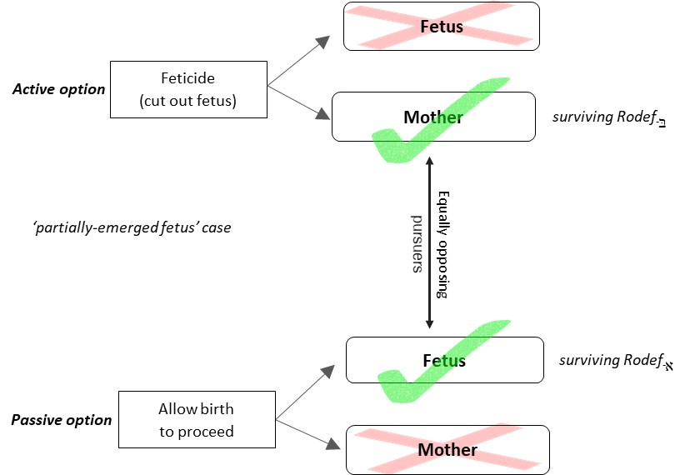

“ ”: Denotes the saving of a life “”: Denotes the loss of a life

Figure 3: The ‘fugitive with escape capability’ case, as explained by Rav Moshe: The respective survivals of the fugitive and townspeople are “inversely related”: If the active option is chosen (i.e., if the fugitive is handed over), the townspeople will live at the expense of fugitive’s life. If the passive option is chosen, the fugitive will escape and live while the townspeople will be killed. Therefore, the fugitive and the townspeople pursue each other equally and the מאי חזית_{Rodef} logic determines that we may not apply the דין רודף.
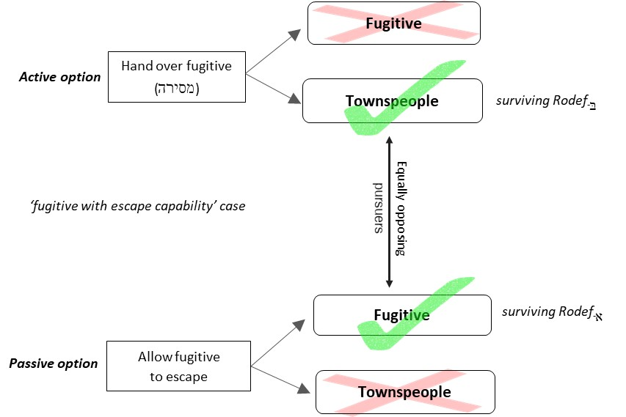
“ ”: Denotes the saving of a life “”: Denotes the loss of a life

  - However, this “flips” our original question (in paragraph 3, p. 14) “on its head". By his own definition of משׁמיא קא רדפי לה, how can Rav Moshe explain the permissibility to kill the ‘non-emerged fetus’ or to hand over the ‘fugitive without escape capability’ based on the דין רודף? Since all the obstructed labor and fugitive situations involve bidirectional רדיפה, we always have a
מאי חזית_{Rodef} dilemma and therefore, the דין רודף should not apply?
  - Rav Moshe explains that in the ‘non-emerged fetus’ and ‘fugitive without escape capability’ cases, Rodef_{-א} has a lower “level” of life than Rodef_{-בּ}. In the ‘non-emerged fetus’ case, the fetus has an “incomplete נפשׁ” status whereas the mother has a “complete נפשׁ” status. Similarly, in the ‘fugitive without escape capability’ case, the fugitive only has transient life (חיי שׁעה, i.e., short stay of execution until the hooligans invade the city and kill everyone if the townspeople do not hand him over), while the townspeople have the potential for normal life expectancy (חיי עולם) if they hand him over. Therefore, we say that there is a “differential” (abbreviated with the symbol “Δ”) between the respective “life-levels” of Rodef_{-א} and Rodef_{-בּ}. Only Rodef_{-א} pursues after this Δ and therefore, with respect to this Δ, only Rodef_{-א} is a רודף. Since they are not equal pursuers (with respect to the Δ), Rodef_{-א} is assigned the “definitive רודף” status and thus, there is no מאי חזית_{Rodef} dilemma. Accordingly, the דין רודף will be applied to permit sacrificing the ‘non-emerged fetus’ or ‘fugitive without escape capability’ to save the mother or townspeople, respectively
Note: See Table 3, p. 21 and Figure 4, p. 22, for depiction of the “differential” (Δ) concept.
Note: The expression “definitive רודף” status, in reference to Rodef_{-א} (the fetus or fugitive), is not intended to suggest that Rodef_{-א} is considered more responsible (or a greater contributor) than Rodef_{-בּ} for the perilous situation they are in. It is merely a convention that was created to refer to Rav Moshe’s explanation that Rodef_{-א} alone pursues a “differential” between their “life levels”.
    - In the case of ‘non-emerged fetus’, only the fetus pursues after the נפשׁ-Δ between the complete נפשׁ of the mother and his own incomplete נפשׁ. Therefore, the fetus has the “definitive רודף” status and the דין רודף will permit killing him to save his mother. However, after the emergence of his head, since both the mother and the fetus have a complete נפשׁ, there is no נפשׁ-Δ between them. Therefore, they are equal רודפים and the דין רודף cannot be applied because of the מאי חזית_{Rodef} logic (Source 17).
    - Similarly, in the case of the ‘fugitive without escape capability’, only the fugitive pursues after the life expectancy-Δ between the townspeople’s חיי עולם (normal life expectancy) and his own חיי שׁעה (transient life). Therefore, the fugitive has the “definitive רודף” status and the דין רודף will permit handing him over to save the townspeople (see Figure 5, p. 23, for a schematic diagram of the ‘fugitive without escape capability’ case). However, if he can escape, since both the fugitive and the townspeople have potential for חיי עולם, there is no life expectancy-Δ between them. Therefore, they are equal רודפים and the דין רודף cannot be applied because of the מאי חזית_{Rodef} logic (Source 18).
However, [the ‘non-emerged’] fetus does not yet have a complete נפש, as we deduce from the fact that one does not incur capital liability (for killing an unborn fetus). Therefore, regarding the advantage (i.e., the נפש-Δ) that the mother has over the fetus – that she is a complete נפש while he is not yet a complete נפש – only the fetus is a רודף and his mother is not a רודפת (pursuer). Therefore, the דין רודף applies to the fetus because of the advantage that the mother has over him. | אגרות משה ,יורה דעה ח״ב, סימן ס׳, ענף ב׳:  אבל בעובר שעדיין אינו נפש גמור כדחזינן שאין נהרגין עליו, ונמצא שעל היתרון של האם מהעובר שהיא נפש גמור והוא אינו עדיין נפש גמור, הוי רק העובר רודף והאם אינה רודפת. לכן יש להעובר דין רודף מחמת היתרון זה שיש להאם עליו.
Source 17: Rav Moshe’s explanation why the דין רודף applies to the ‘non-emerged fetus’ (See Supplement 2, pp. 65-66, 70-71):
Source 18: Rav Moshe’s explanation why the דין רודף applies to the ‘fugitive without escape capability’ (See Supplement 2, pp. 67, 69):
However, if it is evident that everyone will die [including the fugitive, if they remain passive] ... the townspeople only pursue after the fugitive’s חיי שׁעה (transient life) while he pursuers after all their life (חיי עולם - normal life expectancy). Thus, regarding the essential life – which is the advantage (i.e., the life expectancy-Δ) that the townspeople have over the fugitive’s חיי שׁעה – the fugitive pursues after them while they do not pursue after him at all. Thus, the דין רודף applies to the fugitive despite his lack of intent to harm, since he nevertheless is the cause [of their impending danger]. | אגרות משה ,יורה דעה ח״ב, סימן ס׳, ענף ב׳:  אבל באם ברור שימותו כולם ... נמצא שהם רודפים אותו רק על חיי שעה והוא רודף אותם בכל חייהם. הרי נמצא שעל עיקר החיים שהוא היתרון מחיי שעה, הוא רודף אותם והם אינם רודפים אותו כלל, יש לו דין רודף אף שהוא שלא בכוונה כיון שעל כל פנים הוא הסבה.
Table 3: Description of “differentials” between the participant’s respective “levels” of life in the ‘non-emerged fetus’ and ‘fugitive without escape capability’ cases
Case | Participant | “Level” of life | Type of  “differential” | Abbreviation for “differential”
‘non-emerged fetus’ | Fetus | incomplete נפשׁ | נפשׁ-differential | נפשׁ-Δ
 | Mother | complete נפשׁ
‘fugitive without escape capability’ | Fugitive | חיי שׁעה | life expectancy-differential | life expectancy-Δ
 | Townspeople | חיי עולם

Figure 4: The “differential” (Δ) in the ‘non-emerged fetus’ and ‘fugitive without escape capability’ cases: The term “level” refers to “life-level”, either the “נפש-level” or the “life expectancy-level”. Rodef_{-בּ}’s “Level 2” is higher than, and is inclusive of, Rodef_{-א}’s “Level 1”. The Δ refers to the “differential” between “Level 1” and “Level 2”. Accordingly, only Rodef_{-א} pursues after the Δ and therefore, he has the “definitive רודף" status.
Case | Rodef_{-א} |  | Rodef_{-בּ}
 | Name | “Level 1” | Name | “Level 2”
‘non-emerged fetus’ | Fetus | incomplete נפש | Mother | complete נפש
‘fugitive without escape capability’ | Fugitive | חיי שׁעה  transient life | Townspeople | חיי עולם  normal life expectancy
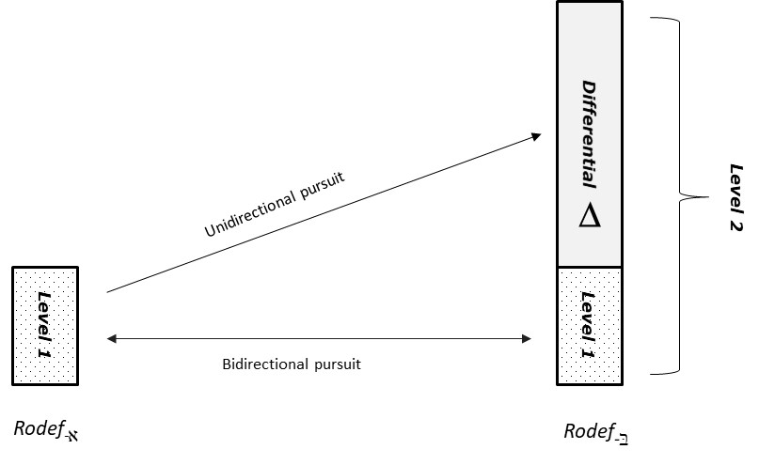
Figure 5: The ‘fugitive without escape capability’ case: If the active option is chosen (i.e., if the fugitive is handed over), the townspeople will live at the expense of the fugitive’s life. If the passive option is chosen, both the fugitive and townspeople will only have שׁעה חיי (temporary life extension). Since there is a life expectancy-Δ between them, they do not pursue each other equally and there is no מאי חזית_{Rodef} dilemma.
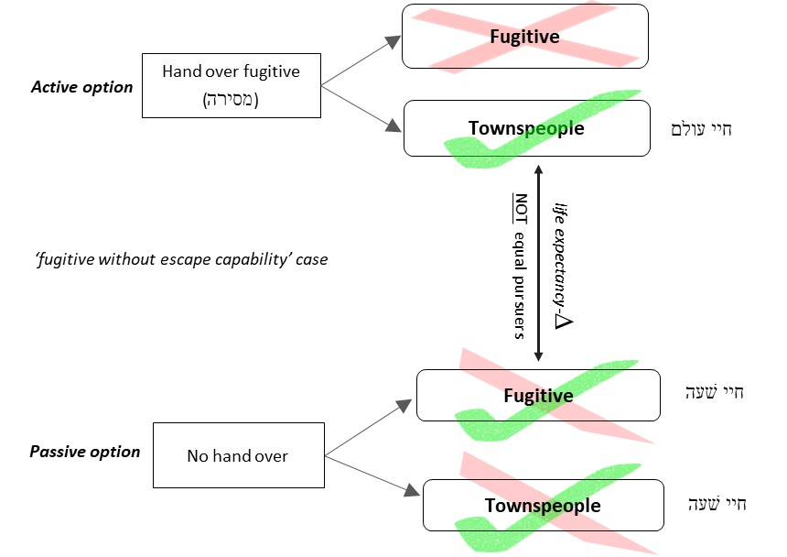
“ ”: Denotes the saving of a life “”: Denotes the loss of a life
“ ”: Denotes the temporary extension of life
Type of Situation | Sub-  category | Who will be saved, as a consequence of choosing  the ________ option? |  | Does ²Rodef_{-א} pursue a ³Δ between the “life-levels” of Rodef_{-א} and Rodef_{-בּ} ? |  | ⁴Does משׁמיא קא רדפי לה apply? | Who is assigned “definitive-רודף"  status? | How does the Halacha decide?  which option?
 |  | ¹Active | Passive | Yes/  No | Explanation
Obstructed labor | non-  emerged fetus | Mother’s complete  נפש | Fetus’ incomplete נפש | Yes | The fetus pursues the ³Δ between the mother’s completeנפש and his own incomplete נפש. | No | Fetus | Active  (Feticide)
 | partially- emerged fetus | Mother’s complete  נפש | Fetus’  complete  נפש | No | The fetus and mother equally pursue each other’s  complete נפש. | Yes | No one | Passive
Fugitive | with  escape capability | ⁵TP’s  ⁶חיי עולם | Fugitive’s  ⁵חיי עולם | No | The fugitive and TP equally pursue each other’s חיי עולם. | Yes | No one | Passive
 | without escape capability | ⁵TP’s  ⁶חיי עולם | Fugitive’s  ⁷חיי שׁעה | Yes | The fugitive pursues the ³Δ between the TP’s חיי עולם and his own חיי שׁעה. | No | Fugitive | Active  ⁸(מסירה)
Table 4: Summary of Approach # 2, (approach of Rav Moshe), to explain the different rulings in the obstructed labor and fugitive situations:
Based on the position that an unintentional pursuer has a status of a רודף.
¹The active option is as follows: In the obstructed labor situation: feticide; in the fugitive situation: hand-over (מסירה).
²Rodef_{-א} = fetus or fugitive; Rodef_{-בּ} = mother or townspeople; ³Δ = “differential”, either a נפש-Δ or a life expectancy-Δ.
⁴For simplicity purposes, this can be regarded as synonymous with: “Is there a מאי חזית_{Rodef} dilemma?”.
⁵TP = Townspeople
⁶חיי עולם = Normal life expectancy; ⁷חיי שׁעה = Transient life (expectancy);
⁸ריש לקיש maintains that מסירה is only permitted if the hooligans imposed a “death sentence” (they have a grievance) against the ‘fugitive without escape capability’.

- Application of אין דוחין נפשׁ מפני נפשׁ and the דין רודף to the multifetal pregnancy (MFP) situation:
  - The following discussion refers to a hypothetical sextuplet pregnancy (6 fetuses), in which:
    - There is a high probability of fatality for all fetuses either in utero or shortly after birth, if MPR is not performed. In this scenario, “F_{reduce}” = the 3 fetuses that the physician wishes to reduce, and “F_{save}” = the remaining 3 fetuses that the physician wishes to save.
    - All fetuses have the same potential to survive if other fetuses are reduced.
    - No fetus displays a gross abnormality or malformation (based on ultrasound imaging studies).
  - In light of the above discussions, several arguments can be made to either allow or prohibit MPR:
    - On one hand, perhaps the principle of אין דוחין would forbid performing MPR even though it would increase the survival probability of the remaining fetuses, since we would be forced to save some lives at the expense of others.
    - On the other hand, just as we are permitted to hand over the ‘fugitive without escape capability’ where everyone would die if the townspeople remained passive, perhaps we should be permitted to reduce some of the fetuses to save the others if all fetuses are otherwise likely to perish (without MPR). We have looked at two different approaches for the permissibility to hand over the ‘fugitive without escape capability’ (i.e., the permissibility for מסירה). The logic inherent in each of these approaches may also provide a basis to permit MPR.
      - Approach 1 - Chasdei Dovid: The permissibility for מסירה is based on the inapplicability of the מאי חזית logic. Since the fugitive will die whether or not the townspeople hand him over, the logic of מאי חזית does not apply.
      - Approach 2 - Rav Moshe: The permissibility for מסירה is based on the דין רודף since the fugitive is considered a רודף after the townspeople.
    - Rabbi Dr. Zalman Levine (Reference 6) suggests that the מאי חזית logic may not apply in a MFP situation where there is a high risk of total fetal/neonatal death without reduction. Therefore, just as the inapplicability of the מאי חזית logic permits מסירה (when the fugitive is unable to escape, according to the Chasdei Dovid, Approach 1), this approach may also permit MPR.
    - According to Rav Moshe (Approach 2), perhaps each fetus in an MFP situation has the status of a רודף after the other fetuses. Just as the דין רודף permits מסירה (when the fugitive is unable to escape, according to Rav Moshe) despite the absence of volition to harm or wrongdoing, perhaps the דין רודף will permit MPR if the passive option is likely to lead to total fetal/neonatal death.
This approach is problematic, however, because Rav Moshe explains that the permissibility to hand over the ‘fugitive without escape capability’ is based on the fugitive being considered the “definitive רודף" due to the life expectancy-Δ between himself and townspeople. By MFP, there is no life expectancy-Δ between the fetuses, assuming all have the same survival probability. Accordingly, even if the fetuses are considered pursuers (רודפים), they all equally pursue after each other, and thus, we have a מאי חזית_{Rodef} dilemma: Why do you presume that that F_{reduce} pursues after F_{save} more than F_{save} pursues after F_{reduce} ? Apparently, it does not seem possible for the דין רודף to permit MPR?
  - In personal correspondence with Rabbi Dr. Zalman Levine (Reference 6), Rav Yosef Sholom Elyashiv ruled that the single deciding factor for permitting MPR is the probability of mortality for each of the fetuses. Rav Elyashiv permitted MPR (in a specific case presented to him by Rabbi Dr. Levine) if the probability of all fetuses perishing was greater than 50%. In addition, Rav Elyashiv ruled that major disability or morbidity (which is common in surviving multifetal-pregnancy babies) may not be considered a factor in allowing MPR.
  - In Sefer Nishmat Avraham (Source 19), Rabbi Dr. Abraham records the ruling of Rav Shlomo Zalman Auerbach (henceforth referred to as “Rav Shlomo Zalman”) who permitted MPR in “cases where the pregnancy is at high risk” on the basis that “each of the fetuses has the status of a רודף”. I do not know the risk level necessary to be considered a “high risk” to the pregnancy, in order to permit MPR according to Rav Shlomo Zalman. Similarly, Rav Mordechai Eliyahu wrote that if all fetuses will otherwise die, each fetus is a רודף after the others and therefore, MPR would be permitted (Reference 11).
Source 19: Rav Shlomo Zalman Auerbach permits MPR in certain cases of high risk to the pregnancy based on the דין רודף; Sefer Nishmat Avraham. (See Supplement 1, Source 11, p. 58, for a more extensive excerpt).
The Gaon, Rav Shlomo Zalman Auerbach, ZT”L, explained to me that in cases where the pregnancy is at high risk due to multiple fetuses, *each of the fetuses has the status of a רודף and therefore the physicians are permitted to select those fetuses for reduction whose termination will cause the least risk of aborting the entire pregnancy. He also agreed that this is permissible even beyond 40 days ....  The Gaon, Rav Yosef Sholom Elyashiv, Shlita (now, ZT”L) told me since the doctors state there is a risk in a quadruplet pregnancy that all the fetuses will be miscarried, it is permitted to reduce. On the other hand, it is known to me that the Gaon (Rav Elyashiv), Shlita, forbade reducing a triplet pregnancy. | נשמת אברהם חושן משפט סימן תכה:  הסביר לי הגאון זצ"ל שבמקרה של הריון בסיכון גבוה עקב ריבוי עוברים כל אחד מהעוברים יש לו דין של רודף ולכן מותר לרופא להרוג חלק מהם בזריקה בבחירת אותם לפי שיקול רופאי שהריגתם יגרום לסיכוי הקטן ביותר של הפלת כולם. והוא זצ"ל גם הסכים שמותר לעשות זאת אחרי ארבעים יום ....ואמר לי הגרי"ש אלישיב שליט"א שכיון שהרופאים אומרים שיש סכנה ברביעיה שתפיל את כולם, מותר לדלל. מאידך ידוע לי שהגאון שליט"א אסר דילול בשלישיה
*If none of the fetuses displays abnormalities (which is our hypothetical case), the physician selects the fetus(es) to be reduced based on their position in the uterus (per Rabbi Dr. Levine, Reference 6). It is beyond my level of understanding to determine whether such a selection is Halachically equivalent to the designation required to permit מסירה in the fugitive case, or even if such equivalency would be necessary to permit MPR based on the דין רודף.
- Possible approach to permitting MPR based on Rav Moshe Feinstein’s explanation of the דין רודף:
Note: Rav Moshe has not published any ruling on the permissibility of MPR (possibly because this procedure was not yet clinically well established during his life time). Thus, any thoughts below are intended as merely an attempt to logically extend Rav Moshe’s Halachic analysis from the fugitive and obstructed labor situations discussed above, to multifetal pregnancy.
  - Rav Hershel Schachter (Reference 12) explains that the position of Rav Moshe, i.e., the prohibition of feticide is included under לא תרצח, is based upon the eventuality that a fetus would become a viable born person. Therefore, if the physicians state with near-certainty that all fetuses will die unless MPR is performed, since the eventuality of a viable born person does not exist, there would be no prohibition of לא תרצח. Therefore, MPR would be permitted to save the remaining fetuses in such cases. According to this approach, Rav Moshe would presumably not agree with Rav Elyashiv that a mortality risk of merely greater than 50% suffices to permit MPR. Rather, a much higher mortality risk would likely be required to permit MPR.
  - Above (VII-2-D, pp. 25-26), we suggested the possibility that perhaps Rav Moshe would consider each fetus as a רודף after the others and accordingly, the דין רודף would provide the basis for permitting MPR, which is the position of Rav Shlomo Zalman. However, we challenged this supposition: Since there is no life expectancy-Δ between fetuses, the מאי חזית_{Rodef} logic (Why do you presume that F_{reduce} pursues after F_{save} more than F_{save} pursues after F_{reduce} ?) would prevent the דין רודף from permitting MPR?
  - I would suggest that the key to determining whether the דין רודף can be applied to permit MPR is by assessing if the concept of משׁמיא קא רדפי לה extends to the MFP situation. If the משׁמיא קא רדפי לה concept applies to MFP, then, just as in the ‘partially-emerged fetus’ and ‘fugitive with escape capability’ cases, we cannot apply the דין רודף and thus, MPR would be forbidden. Conversely, if the משׁמיא קא רדפי לה concept does not apply to MFP, the דין רודף could be applied (just as in the ‘fugitive without escape capability’ case) and MPR would be permissible.
  - For purposes of simplicity, I suggest that Rav Moshe’s explanation how the משׁמיא קא רדפי לה concept applies in the ‘partially-emerged fetus’ and ‘fugitive with escape capability’ cases, may be presented as follows: There are two ends of the “active-vs.-passive option spectrum” (abbreviated as “A-vs.-P spectrum”): The “passive end” and the “active end”. At the “passive end”, Rodef_{-א} (the fetus or fugitive) will live at the expense of Rodef_{-בּ} (the mother or townspeople); whereas, at the “active end”, Rodef_{-בּ} will live at expense of the Rodef_{-א} (see Figures 2-3, pp. 18-19). Since we see that their respective survivals are inversely related, it is evident that Heaven has arranged that Rodef_{-א} and Rodef_{-בּ} are equally “opposing רודפים”. Accordingly, we have no basis to assign the “definitive רודף” status to one party more than to the other and thus, the דין רודף cannot be applied.
  - How does this help us determine if משׁמיא קא רדפי לה applies to the MFP situation? Two opposing perspectives are suggested, to either support or oppose applying משׁמיא קא רדפי לה to MFP.
    - On one hand, there are two analogies between the MFP situation and the ‘fugitive with escape capability’ case: (1) Each fetus in the MFP situation has a similar potential to survive if other fetuses are reduced, and thus, there is no life expectancy-Δ between the fetuses; (2) Since F_{save} can only live if F_{reduce} is reduced and visa versa, therefore, the respective survivals of all the fetuses are inversely related. From this vantage point, we should say that all fetuses pursue after each other equally. Accordingly, just as in the ‘fugitive with escape capability’ case, the
משׁמיא קא רדפי לה concept should apply and theדין רודף would not apply to permit MPR.
    - On the other hand, a strong argument could be made against applying משׁמיא קא רדפי לה to MFP, as follows: At the “passive end” of the “A-vs.-P spectrum” (i.e., if MPR is not performed), no fetus is likely to live at the expense of another fetal life since there is a high risk of total fetal/neonatal death. Only at the “active end” (i.e., if MPR is performed), some fetuses (i.e., F_{save} ) will live at the expense of the others (i.e., F_{reduce} ) (see Figure 6, p. 31). Accordingly, the survivals of F_{save} and F_{reduce} are not truly inversely related in the same manner as in the ‘partially-emerged fetus’ and ‘fugitive with escape capability’ cases. Therefore, we would not say that Heaven has arranged that all parties pursue each other equally. Accordingly, the משׁמיא קא רדפי לה concept would not apply to the MFP situation in question and theדין רודף could permit MPR despite the absence of a life expectancy-Δ.
  - Thus, we have arguments both to support and oppose applying משׁמיא קא רדפי לה to the MFP situation. I would like to suggest the following approach why the משׁמיא קא רדפי לה concept should not apply to the MFP situation and thus, theדין רודף would permit MPR.
    - In the חידושי רבינו חיים הלוי על הרמב”ם (Reference 8), Rav Chaim states, “The רמב״ם understands that the תורה’s authorization for killing the רודף is based on the imperative of saving the life of the pursued party (הצלת הנרדף).” In the ‘partially-emerged fetus’ and ‘fugitive with escape capability’ cases, whether we choose the active option or passive option, we will save the life of a נרדף since each רודף is simultaneously also a נרדף. If we choose the passive option, Rodef_{-א} (the fetus or fugitive) is the נרדף who will be saved and if choose the active option, Rodef_{-בּ} (the mother or townspeople) is the נרדף who will be saved. Since the entire purpose of theדין רודף is to save the נרדף, unless we know that one of the “opposing parties” has the “definitive רודף” status, we should choose the passive option since we are saving a נרדף without actively taking a life. This would seem to fit with Rav Moshe’s explanation of משׁמיא קא רדפי לה: The same Heavenly process that caused the mother (Rodef_{-בּ}) to be the object of the fetus’ (Rodef_{-א}’s) pursuit, i.e., that she would suffer such a difficult labor that she cannot live if the fetus’ life is spared, has also caused the fetus to become the object of the mother’s pursuit. Since the fetus is an equal נרדף as the mother is, there is just as much imperative to save his life as there is to save his mother’s life. The מאי חזית_{Rodef} logic, therefore, dictates that we choose the option of saving a נרדף which would not require actively taking a life. Only if we know that Rodef_{-א} is the “definitive רודף” (in the ‘non-emerged fetus’ and ‘fugitive without escape capability’ cases), which is another way of saying Rodef_{-בּ} is the “definitive נרדף”, the imperative of saving Rodef_{-בּ} determines that we must choose the active option.
    - However, in the MFP situation, there is only one option that would result in saving a נרדף, i.e., the active option (MPR). The passive option is not likely to save any lives. Therefore, the imperative of saving the life of a נרדף should determine that we choose the active option, i.e., we should perform MPR to save some of the fetuses.
  - Rav Moshe’s use of the מאי חזית_{Rodef} terminology in the context of the ‘partially-emerged fetus’ and ‘fugitive with escape capability’ cases, may be analogous to Rashi’s understanding of the מאי חזית logic in the “coerced murder” case.
    - Rav Moshe portrayed Rashi’s view of the מאי חזית logic in the “coerced murder” case as “two negative consequences vs. one negative consequence” (see Figure 1, p. 5).
    - Similarly, in the ‘partially-emerged fetus’ and ‘fugitive with escape capability’ cases, we have a “standoff” between two options:
      - If we choose the passive option, there will be one positive consequence, הצלת הנרדף (saving the pursued party), without performing an act of שׁפיכת דמים (murder).
      - If we choose the active option, there will be a positive consequence, הצלת הנרדף, but there will also be a negative consequence, an act of שׁפיכת דמים.
    - Thus, we have a “standoff” between: (1) the passive option, which will only produce a positive consequence; vs. (2) the active option, which will produce both a positive and a negative consequence. Therefore, the מאי חזית_{Rodef} logic dictates that we should choose the passive option which will only produce a positive consequence.
  - However, in the MFP situation, there is no similar “standoff” since the passive option will not likely produce any positive consequence. The only available option which will produce the positive consequence of הצלת הנרדף is the active option, i.e., performing MPR. Therefore, the מאי חזית_{Rodef} logic and thus, the משׁמיא קא רדפי לה concept, will not apply and theדין רודף would permit MPR. The only remaining question is which fetus(es) to select for reduction. Perhaps this is not a question in Halacha, but rather, a strategic medical question, i.e., which fetuses does the physician believe he can reduce while causing the least risk to the remainder of the fetuses as Rav Shlomo Zalman said (Source 19, p. 26).
  - There is a difficulty, however, with this rationale. Previously (VI-8, pp. 20-21), we explained that according to Rav Moshe, the reason why the משׁמיא קא רדפי לה concept does not apply in the ‘fugitive without escape capability’ situation is because of the life expectancy-Δ between the townspeople’s חיי עולם (normal life expectancy) and the fugitive’s חיי שׁעה (temporary life). However, if our rationale by MFP is correct, we should apply the same logic in the ‘fugitive without escape capability’ case, i.e., since the only end of “A-vs.-P spectrum” in which anyone will survive is at the “active end” (i.e., מסירה), the משׁמיא קא רדפי לה concept should not apply. Why does
Rav Moshe need a life expectancy-Δ to explain why משׁמיא קא רדפי לה does not apply in the ‘fugitive without escape capability’ situation?
    - Perhaps we can answer that in the ‘fugitive without escape capability’ situation, even though there would be no survivors if the passive option was chosen, nonetheless, the fugitive would still have חיי שׁעה remaining until the hooligans invade and kill everyone, which he stands to lose if the townspeople hand him over. Therefore, if not for the life expectancy-Δ between the townspeople’s חיי עולם and the fugitive’s חיי שׁעה, we would still have the same dilemma as in the ‘fugitive with escape capability’ situation: If we choose the active option, the fugitive will lose his חיי שׁעה and if we choose the passive option, the townspeople will lose their חיי עולם. Accordingly, we would have reasoned since we can fulfill הצלת הנרדף through the passive option, i.e., temporarily extending the life of the fugitive, we must remain passive rather than performing an act of שׁפיכת דמים. Only because of the life expectancy-Δ, we can say that the respective pursuits of the “opposing parties” are not equal and therefore, the משׁמיא קא רדפי לה concept will not apply.
    - However, in the MFP situation, if we believe that the concept of חיי שׁעה does not exist during fetal life in utero, which is the position of the Yad HaMelech (Reference 13), there will not be any fulfillment of הצלת הנרדף through the passive option. Although the passive option will temporarily prolong the existence of the fetuses, since they do not have חיי שׁעה, this prolongation is not considered life-saving (הצלת הנרדף) at all. Only the active option (MPR) can achieve הצלת הנרדף. Thus, the מאי חזית_{Rodef} logic and the משׁמיא קא רדפי לה concept will not apply despite the absence of a life expectancy-Δ and theדין רודף would permit MPR.

Figure 6: Multifetal pregnancy (MFP) case: If the passive option is chosen, there will not likely be any הצלת הנרדף since there is a high risk of total fetal/neonatal death. Only if the active option (MPR) is chosen, some of the fetuses (F_{save}) will survive at the expense of the other fetuses (F_{reduce}).
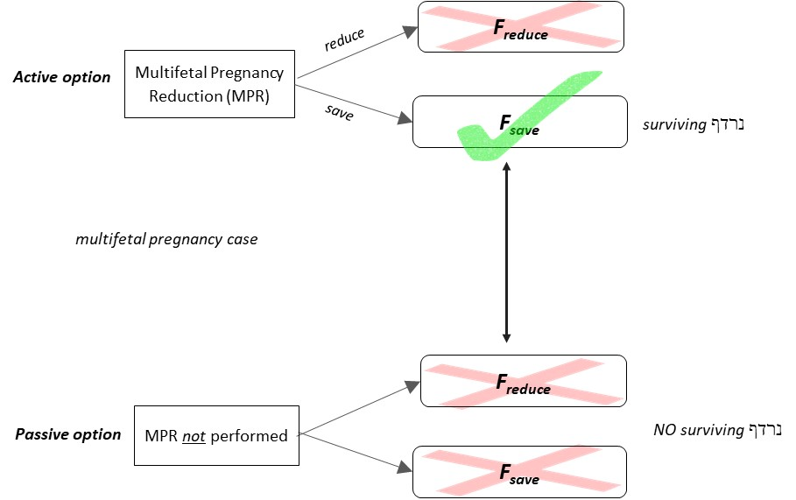
“ ”: Denotes the saving of a life “”: Denotes the loss of a life

- Conclusion
  - Table 5 summarizes Rav Moshe’s analysis of the fugitive and obstructed labor situations and compares these cases to the MFP situation.
  - We discussed several reasons to permit MPR in cases of high risk of total fetal/neonatal death:
    - Rav Shlomo Zalman Auerbach ruled that in cases of high risk to the pregnancy, “each of the fetuses has the status of aרודף ,” and on this basis, he permitted MPR.
    - Rav Hershel Schachter explained that even according to Rav Moshe who believes that feticide usually is a violation of לא תרצח, if there is a near certainty that all fetuses will die without MPR, there would be no prohibition of לא תרצח and therefore MPR would be permitted to save the remaining fetuses.
    - Rabbi Dr. Zalman Levine reasoned that if there is a high probability of fetal death, the מאי חזית logic would not apply (just as in the ‘fugitive without escape capability’ case according to the Chasdei Dovid’s explanation) and therefore MPR would be permitted.
    - Although Rav Moshe did not rule on the permissibility of MPR, perhaps he would agree with
Rav Shlomo Zalman that we apply theדין רודף to permit MPR since Rav Moshe believes that theדין רודף applies even to unintentional pursuit. This approach is based on a suggestion that the מאי חזית_{Rodef} logic and thus, the משׁמיא קא רדפי לה concept, only apply if both the passive and active options can achieve הצלת הנרדף, i.e., in the ‘partially-emerged fetus’ and ‘fugitive with escape capability’ cases. However, in the MFP situation, if we assume that the concept of
חיי שׁעה does not exist during fetal life, the only option that will achieve הצלת הנרדף is the active option (MPR). Therefore, משׁמיא קא רדפי לה will not apply and theדין רודף would permit MPR.
  - The question as to how Rav Moshe would have ruled regarding the permissibility of MPR cannot be definitively answered based on his rulings and insights that we have presented here. If we had the fortune to still have Rav Moshe leading us today, we could be certain that he would have marshaled his immense and profound understanding of all areas of Shas and Poskim, as well as his great Yirat Shomayim and Mesirat Nefesh for K’lal Yisroel to properly determine the Halacha in each type of multifetal pregnancy situation, to guide us through these very critical situations. It is our hope that through this essay, we have, in some small measure, demonstrated the timelessness of the Torah as well as the brilliance and ability of Torah giants such as Rav Moshe to transcend time and to thereby inspire the many to embrace the beauty that was Rav Moshe and that he left for us to further cultivate.
חבל על דאבדין ולא משתכחין, מי יתן לנו תמורתו
Woe is to us that Rav Moshe is lost and not found. Who will give us another as him?

Table 5: Summary of Suggested Analyses of the Fugitive, Obstructed Labor and Multifetal Pregnancy Situations, Based on Rav Moshe’s Insights
Type of Situation | Sub-category | Who will be saved  if the ______  option is chosen? |  | Is there a Δ (differential) between  ²Rodef_{-א} and Rodef_{-בּ} ? |  | Does the משׁמיא קא רדפי לה concept apply?
 |  | ¹Active | Passive | Yes/  No | Explanation | Yes/  No | Why
Obstructed labor | non-  emerged  fetus | Mother’s complete  נפש | Fetus’ incomplete נפש | Yes | Δ between the mother’s complete נפש and the fetus’ incomplete נפש | No | The fetus is considered the  “definitive רודף" because of the נפשׁ-Δ
 | partially- emerged  fetus | Mother’s complete  נפש | Fetus’  complete  נפש | No | Both the fetus and mother have a complete נפש | Yes | מאי חזית_{Rodef}  why do you presume Rodef_{-א} pursues Rodef_{-בּ} more than Rodef_{-בּ} pursues Rodef_{-א} ?  (i.e., they are mutually equal pursuers)
Fugitive | with  escape capability | ³TP’s  ⁴חיי עולם | Fugitive’s  ⁴חיי עולם | No | Both fugitive and TP have potential for חיי עולם
 | without escape capability | ³TP’s  ⁴חיי עולם | Fugitive’s  ⁵חיי שׁעה | Yes | Δ between the TP’sחיי עולם and the fugitive’s חיי שׁעה | No | The fugitive is considered  the “definitive רודף" because  of the life expectancy-Δ
Multifetal Pregnancy  Assume:  High risk of total  fetal/neonatal death  without MPR |  | ⁶F_{save}  (⁷F_{reduce} will  be lost) | High probability:  No one | No | Assume:  All fetuses have the same survival potential if others are reduced. | No | משׁמיא קא רדפי לה only applies if both the passive option and active option would achieve הצלת הנרדף. However, by MFP, the only option that can achieve  הצלת הנרדף is the active option (MPR).
¹The active option is as follows: In the obstructed labor situation: feticide; in the fugitive situation: hand-over (מסירה); in the MFP situation: MPR (fetal reduction)
²Rodef_{-א} = fetus or fugitive; Rodef_{-בּ} = mother or townspeople; ³TP = Townspeople; ⁴חיי עולם = Normal life expectancy; ⁵חיי שׁעה = Temporary life (expectancy)
⁶F_{save} = fetuses that the physician wishes to save; ⁷F_{reduce} = fetuses that the physician wishes to reduce.

- References
1 | תלמידי רבינו יונה על מס׳ עבודה זרה דף כח ע”ב, ד״ה דילמא דמא דחברך סומק טפי  (See Appendix B, Source B-2, p. 45, for an excerpt and translation).
2 | רבי נחום פרצוביץ, ספר זכרון טוב משה, בענין יהרג ואל יעבור
3 | אגרות משה, יורה דעה ח״ב, סימן קעד׳, ענף ד׳  (See Supplement 2, pp. 83-85, for excerpts and translation).
4 | דינא דחיי על ספר מצוות גדול, לאווין קסד׳  (See Supplement 1, Source 6c, pp.54-55, for an excerpt of the Sefer Mitzvot Gadol and Dina Dechayei).
5 | חזון איש על מס׳ סנהדרין, סימן כה׳  (See Supplement 1, Source 10, pp.57-58, for an excerpt and translation).
6 | Rabbi Dr. Zalman Levine: “Multi Fetal Reduction”; audio file on YUTorah.org, October 2007
7 | אגרות משה, חושן משפט ח״ב, סימן סט׳, אות א׳-ב׳  (See Supplement 2, pp. 63-66, for excerpts and translation).
8 | חידושי רבינו חיים הלוי על הרמב"ם הל’ רוצח ושמירת הנפש, פרק א׳ הלכה ט׳  (See Supplement 3, pp. 91-94, for full Hebrew text and partial translation).
9 | דברי יששכר, חושן משפט, סימן קסח׳  (See Supplement 1, Source 13, pp.60-61, for an excerpt and translation).
10 | אבי עזרי על הרמב"ם הל’ רוצח ושמירת הנפש, פרק א׳ הלכה ו׳, הלכה ט׳  (See Supplement 4, pp. 95-99, for excerpts and translation).
11 | הרב מרדכי אליהו, תחומין, השמדת ביציות מופרות ודילול עוברים, כרך יא, תש"ן, עמ' 272
12 | Rabbi Hershel Schachter: “Fetal Reduction”; audio file on YUTorah.org, March 2002
13 | יד המלך על הרמב״ם הל’ שׁבת, פרק ב׳ הלכה יח׳  (See Supplement 1, Source 16, pp.62-62A, for an excerpt of the Yad Hamelech).

